How To Upgrade Security Module

1. Remove 2 screws and connect RS232 cable.

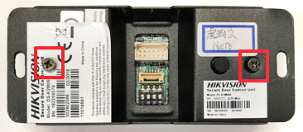 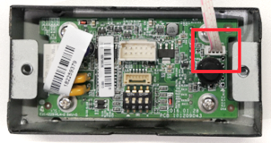

1. Start SecureCRT.

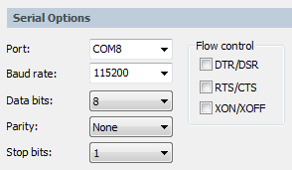

1. Reboot device and press u to stop booting. Input 1 to enter upgrading mode.

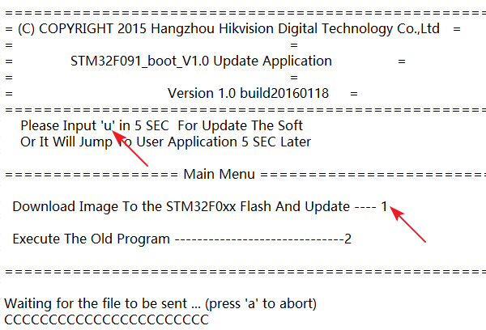

1. Send serial.bin firmware by Ymodem option.

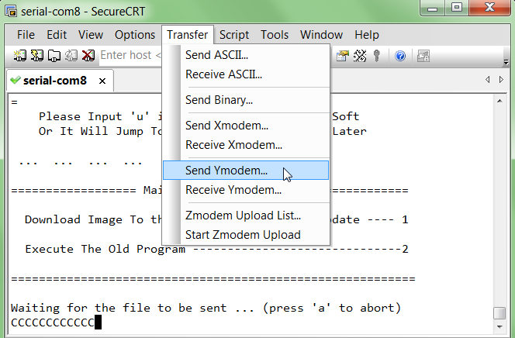

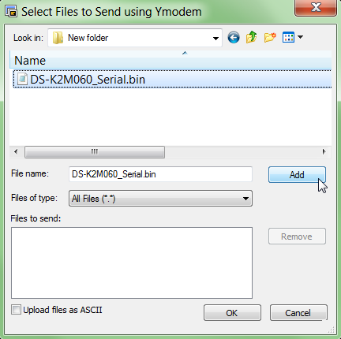 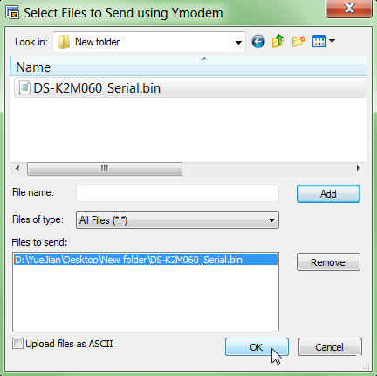

1. New firmware version will be shown after reboot.

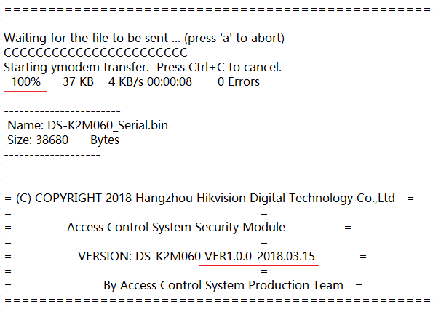

[ - The End - ]