iVMS-4200 Client Software
User Manual

Hangzhou Hikvision Digital Technology Co., Ltd.

Notices

The information in this documentation is subject to change without notice and does not represent any commitment on behalf of HIKVISION. HIKVISION disclaims any liability whatsoever for incorrect data that may appear in this documentation. The product(s) described in this documentation are furnished subject to a license and may only be used in accordance with the terms and conditions of such license.

Copyright © 2006-2011 by HIKVISION. All rights reserved.

This documentation is issued in strict confidence and is to be used only for the purposes for which it is supplied. It may not be reproduced in whole or in part, in any form, or by any means or be used for any other purpose without prior written consent of HIKVISION and then only on the condition that this notice is included in any such reproduction. No information as to the contents or subject matter of this documentation, or any part thereof, or arising directly or indirectly therefrom, shall be given orally or in writing or shall be communicated in any manner whatsoever to any third party being an individual, firm, or company or any employee thereof without the prior written consent of HIKVISION. Use of this product is subject to acceptance of the HIKVISION agreement required to use this product. HIKVISION reserves the right to make changes to its products as circumstances may warrant, without notice.

This documentation is provided “as-is,” without warranty of any kind.

Please send any comments regarding the documentation to:
overseasbusiness@hikvision.com

Find out more about HIKVISION at www.hikvision.com

Contents
Notices 1
Contents 2
Chapter1. Overview 4
1.1 Description 4
1.2 Features & Functions 4
Chapter2. Update Info 5
Chapter3. Starting iVMS-4200 6
3.1 Installing the Software 6
3.2 Uninstalling the Software 11
3.3 User Registration 12
3.4 Import Camera Wizard 13
3.5 User Login 16
3.6 Control Panel Introduction 17
3.7 Account Management 20
Chapter4. Adding Devices 22
4.1 Adding Device 22
4.1.1 Adding Device 22
4.1.2 Device Configuration 24
4.2 Adding a Stream Media Server 25
4.3 Adding a Camera Group 26
Chapter5. Live View & Control 28
5.1 Main View Interface 28
5.2 Starting Live View 30
5.3 Capture in Live View 31
5.4 PTZ Control 32
5.4.1 Preset 34
5.4.2 Pattern 34
5.4.3 Patrol 35
5.5 Alarm / Event View 36
5.5.1 View Alarm /Event Information 36
5.5.2 Alarm Log Linkage 38
Chapter6. Recording 40
6.1 Local Recording 40
6.2 Storage Server Recording 40
6.2.1 Adding Storage Server 40
6.2.2 Setting Storage Server Recording Schedule 42
6.3 Remote Recording 45
Chapter7. Playback 47
7.1 Playback of Local Stored Files 47
7.2 Instant Playback 48
7.3 Event Playback 50
7.4 Remote Playback 52
Chapter8. Backup 55
8.1 Backup Captured Pictures 55
8.2 Record Files Backup 56
Chapter9. Camera & Device Configuration 59
9.1 Camera Settings 59
9.1.1 Image Quality 60
9.1.2 Video Quality 61
9.1.3 Schedule 62
9.1.4 Video Display 64
9.1.5 Motion Detection 66
9.1.6 Tampering Alarm 67
9.1.7 Video Loss 69
9.1.8 PTZ Control 70
9.1.9 Network Connection 70
9.2 Device Configuration 71
9.2.1 Information 73
9.2.2 General 73
9.2.3 Network 74
9.2.4 Alarm 76
9.2.5 User 78
9.2.6 HDD 79
9.2.7 Exception 80
9.2.8 File 81
9.2.9 Log 82
9.2.10 Holiday 83
9.2.11 Others 84
9.2.12 Channel-Zero 85
Chapter10. E-Map 86
10.1 Adding a E-map 88
10.2 Editing a E-map 90
Chapter11. Decoding Device Management 90
11.1 Adding Decoding Device 90
11.2 Editing TV Wall 92
11.3 Adding Cameras to TV Wall 95
11.4 PC Decoder 96
Chapter12. Log 98
12.1 Log Query 98
12.2 Log Backup 98
12.3 Opening Log File 99
Chapter13. System Configuration 100
13.1 General 100
13.2 File 101
13.3 Alarm Sound 102
13.4 Email 102
Chapter14. FAQ 104
Live View 104
Recording 104
Playback 104
Configuration 105

Chapter1. Overview

1.1 Description
iVMS-4200 Intelligent Video Management System is a newly-developed colligation software which includes not only NVR, DVR, and IP camera management functions but also compression card, decoder connection and setup functions. The powerful functions make it popular in local & remote surveillance of supermarkets, stores, districts and residential places, etc.
This user manual describes the function, configuration and operation steps of iVMS-4200 software. To ensure the properness and stability of the software, please refer to the contents below and read the manual carefully before installation and operation. This user manual can be acquired from your supplier.

1.2 Features & Functions
V1.01.00
- The software contains 5 subsystems: User Client, PC Storage Server, Stream Media Server, Decoding Sever, and Encoding Server.
- Main View: View live video and instant video playback; and various video operations such as capture, recording, PTZ control, etc. are supported.
- E-Map: Manage and display E-Map and hot spots; operate map zoom in/out, view hot spot, display alarm, and other E-Map operations are supported.
- Event Search: Search and playback of the event record files.
- TV Wall View: Configure and operate TV wall for video decoders.
- Camera Import: Add, modify and delete groups and all kinds of camera from Hikvision devices.
- Local Log Search: Search, view and backup different sorts of local logs such as alarm, operation, system logs, etc.
- User Management: Add, modify and delete the user of iVMS-4200; assign operating permissions to each user.
- Device Management: Add, delete, and configure parameters of Hikvision devices, such as network settings, alarm in/out, hard disk management and upgrade, etc.
- NVR Management: Add, modify and delete the storage server; configure parameters (e.g., record schedule, network, HDD, etc.) for the added storage server.
- Stream Media Servers: Add, modify and delete the stream media server; configure parameters (e.g., RTSP port, port upper/lower limit, etc.) for the added stream media server.
- Decoder Server: Add, modify and delete the decoder; configure parameters (e.g., network, alarm input/output, exception, etc.) for the added decoder.
- Camera Configuration: Configure camera parameters (e.g., image quality, record schedule, motion detection, etc.).
- System Configuration: Configure the general settings of iVMS-4200, such as the saving path of captured images, recordings, alarm sound settings and email settings.

Chapter2. Update Info

* This is the first edition.

Chapter3. Starting iVMS-4200

3.1 Installing the Software
Insert the DX4200 resource disc into the remote computer CD/DVD drive, and wait for the window to open.
Follow the installation prompts to install the software.
Step1: Double click the program file to enter the following InstallShield Wizard as shown below:
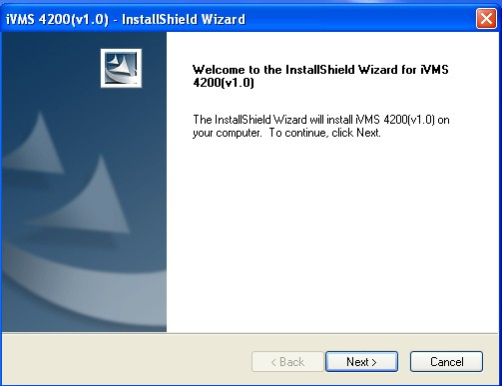
Figure 3.1 Welcome to InstallShield Wizard

Step2: Click “Next” to start the InstallShield Wizard. Select the language (English) for installation, and then click “Next” to continue.
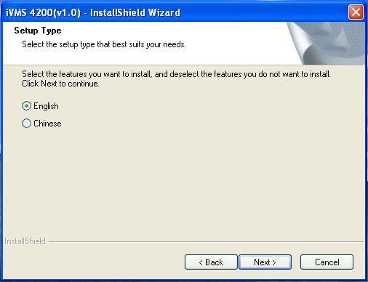
Figure 3.2 Select Language

Step3: Install vcredist_x86 patch/Card Driver/WinpCap
Select the driver you want to install.
vcredist_x86 patch:for X86 operating system
Card Driver: for compression card
WinpCap: for open source software, SADP driver
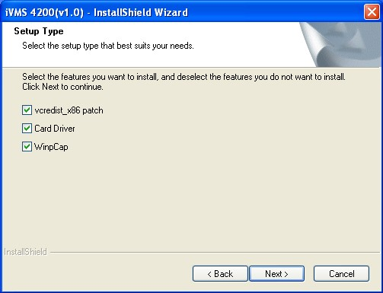
Figure 3.3 Select Driver
Install vcredist_x86 patch
Start to install the vcredist_x86 patch and then click ”Next” to continue.
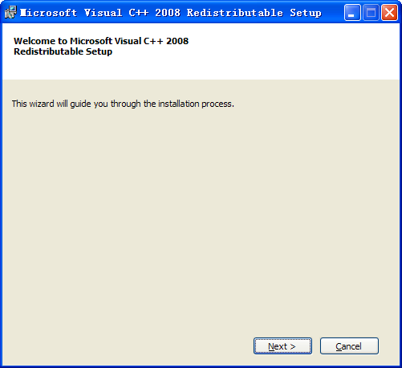
Figure 3.4 Install vcredist_x86 patch-Start Installation

In the License Terms dialog box, click “I have read and accept the license terms”, and then click “Install” to install the vcredist_x86 patch.
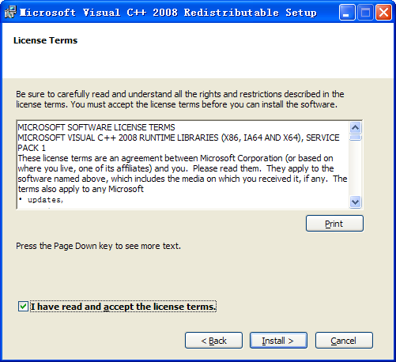
Figure 3.5 Install vcredist_x86 patch-Accept License Terms

After the Setup Complete interface appears, click Finish to complete the installation of vcredist_x86 patch.
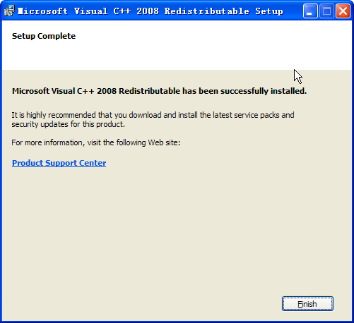
Figure 3.6 Install vcredist_x86 patch-Complete Installation

Install Card Driver
If there is compression card installed on your computer, you can click the “Install or Update Driver” option to install the card driver.

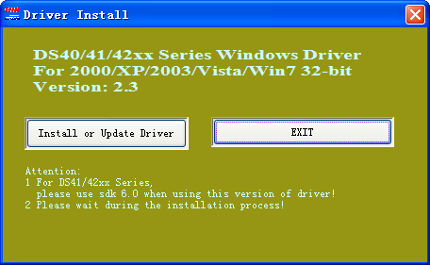
Figure 3.7 Install Card Driver

Install WinPcap
Follow the installation prompt to complete the installation of WinPcap. If it has been installed on your computer, you can cancel this step.

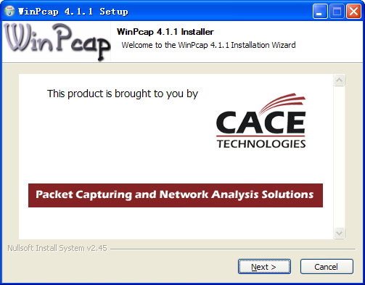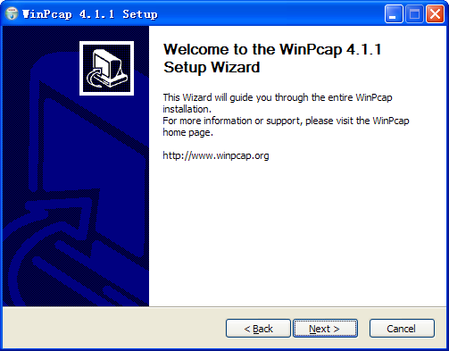
Figure 3.8 Install WinPcap

Note: The SADP is used for automatically searching the online device in the local network. If the WinPcap is not installed, the SADP software cannot be used.

After the driver has been installed, continue the following steps.

Step5: Select the programs you want to install on your computer, including the User Client, PC NVR Server and Stream Media Server. User can also click Browse to change the directory to save the program files.
Click “Next” to continue.
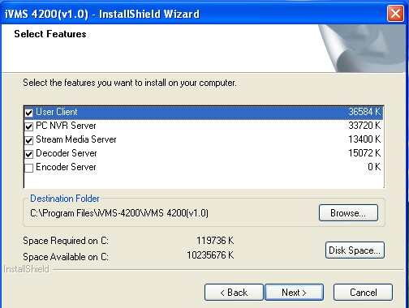
Figure 3.9 Select Installation Programs
Step6: In the License Terms interface, click “I accept the terms of the license agreement”, and then click “Next” to continue the installation.
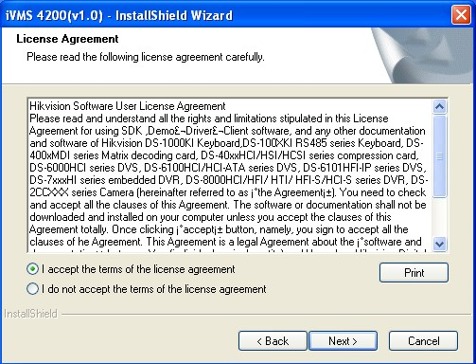
Figure 3.10 Select Installation Programs

Step7: Click “Install” to start installation of the selected programs.
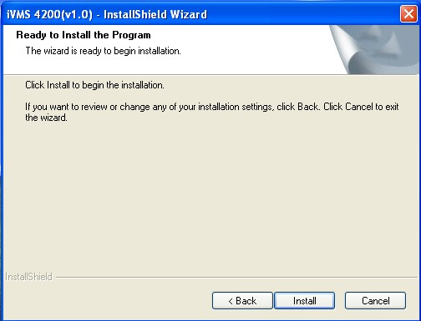
Figure 3.11 Install the Selected Programs

Step8: After the installing progress is completed, enter the Setup Type interface to select the desktop shortcut icons for the installed programs. Click “Next” to continue the installation.
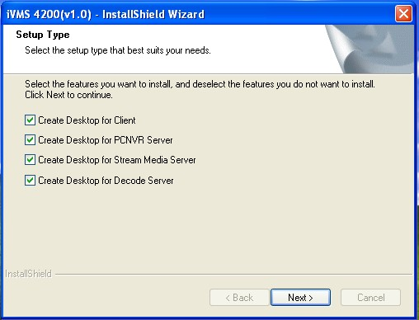
Figure 3.12 Create Desktop Shortcut Icons

Step9: Click “Finish” to complete the installation.
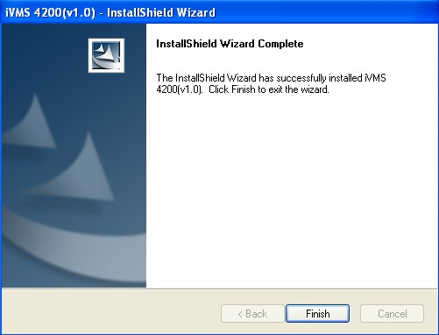
Figure 3.13 Finish the Completion

3.2 Uninstalling the Software
Click StartAll Programs4200 client and select “Uninstall iVMS-4200” option to enter the following interface:
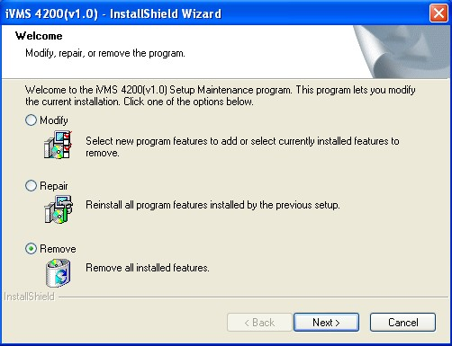
Figure 3.13 Uninstall the Programs

Select “Remove” to remove all installed features and then click “Next” to uninstall iVMS-4200 according to the prompt.

3.3 User Registration
For the first time to use the iVMS-4200 software, you need to register a super user for login.
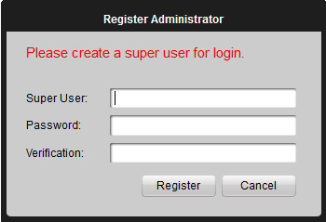
Figure 3.14 User Login

Input the super user name, password and confirm the password in the dialog box and click Register. Then, you can log in as the super user.
Note: Enter, Space, and TAB buttons are invalid for the user name and password. The password cannot be empty, and it should not be less than six characters and can’t be copied and pasted.

3.4 Import Camera Wizard
After registration and login, the following message box will pop up:
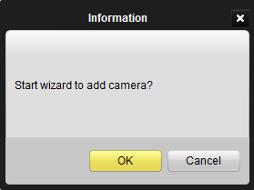

Figure 3.15 Import Camera Wizard

Click OK to start the wizard and add the device, or click Cancel to exit the wizard.
Step1: According to the hint, click Import Camera icon to enter the Camera Import control interface.
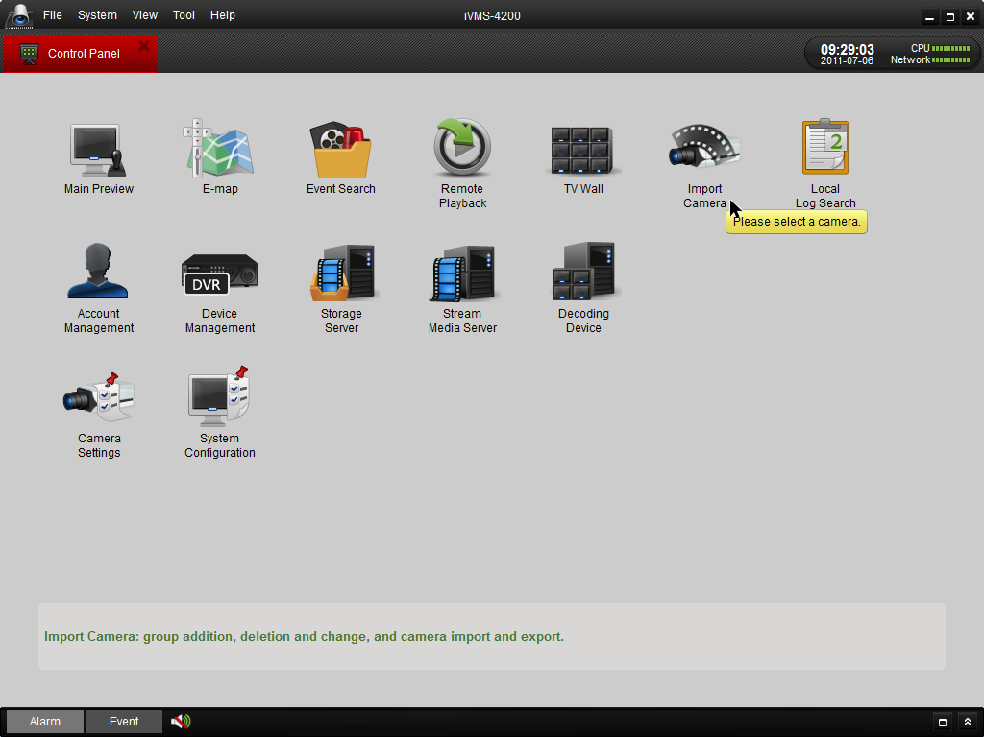
Figure 3.16 Enter Camera Import Interface

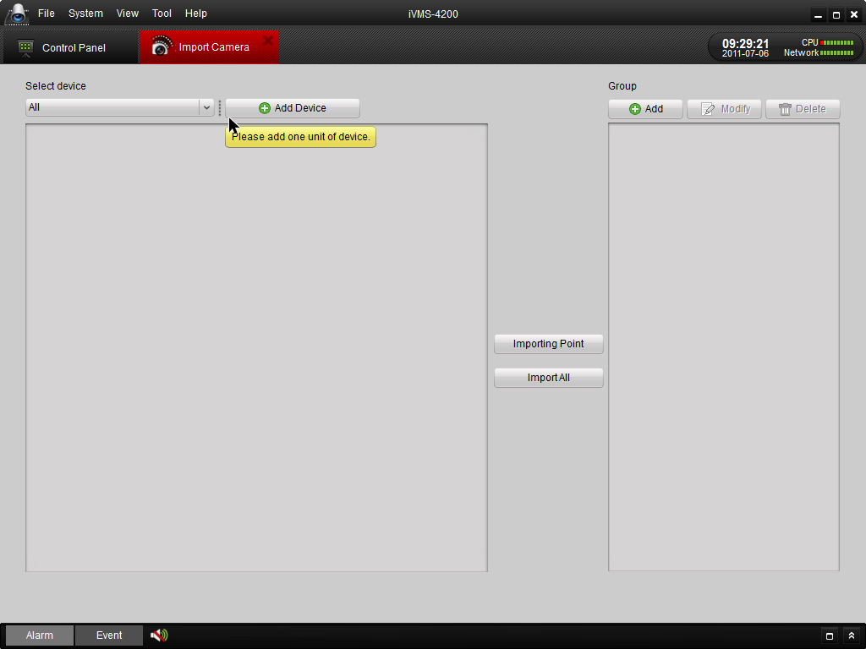
Figure 3.17 Device Management Interface
Step2: Add DVR
Click Add Device and then input the device information and then click Add to enter the device information in the dialog box of Add DVR interface.
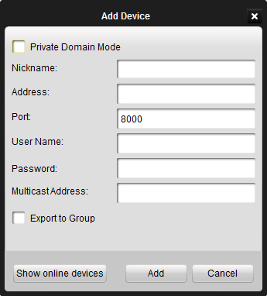
Figure 3.18 Add DVR

Step 3: After adding the device according to the above steps, you will see the toolbar after the device name.
click to enter the Device Parameters configuration interface (Figure 3.19).

Click to edit the connected device settings.
Click to delete the added group.
Click to refresh the page.
Click to import all the monitoring point to the group named by the name of the device.

Step 4: Add Group
After adding DVR, please click the Add on Group dialog box. Edit the name of group and then click OK to save your settings.. The added group will be displayed in the list.
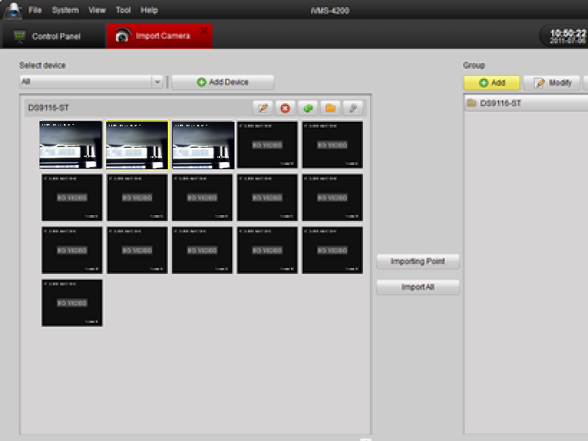
Figure 3.19 Add Group

Step 5: Import Channel to Group
In the left area on the Camera Import interface, click to select the channels and then click Import button to import the selected channels to the Group on the right.
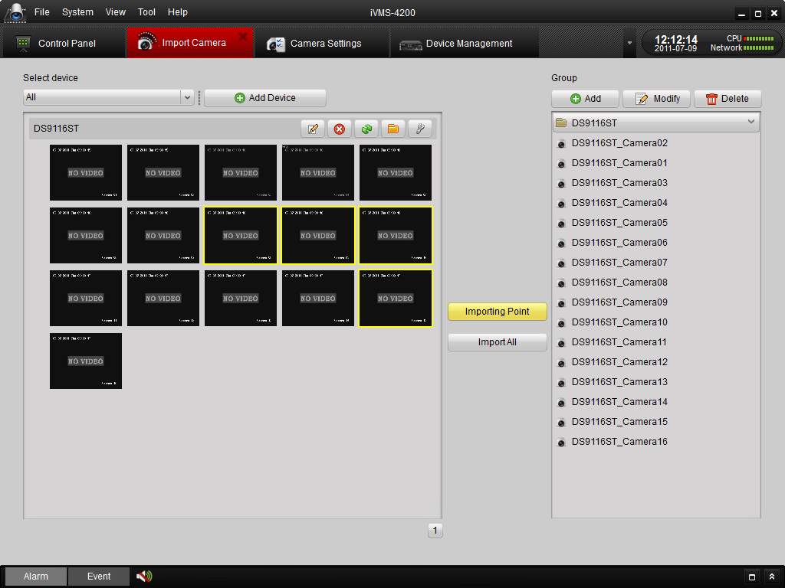

Figure 3.20 Import Channel

Note:
- You can hold the Ctrl key on PC to select multiple channels or click Import All button to select all channels for import.
- The devices to be added must be online currently.
- Each channel can be added to one group only once, while the same channel can be added to different groups.
- Up to 64 channels can be added to each group, with a maximum of 1024 channels for all the groups totally.

Step 6: After importing the selected channels to the group, you can return to the control panel and then enter the Main View interface to get a live view of the added channels.

3.5 User Login
When you open the iVMS-4200 software after registration, the login dialog box pops up, shown as follows:
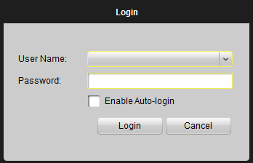
Figure 3.21 User Login
Input the user name and password, and then click Login. You can also enable the auto-login by checking the Enable Auto-login checkbox.

3.6 Control Panel Introduction
The main control panel of the iVMS-4200 is shown as follows:

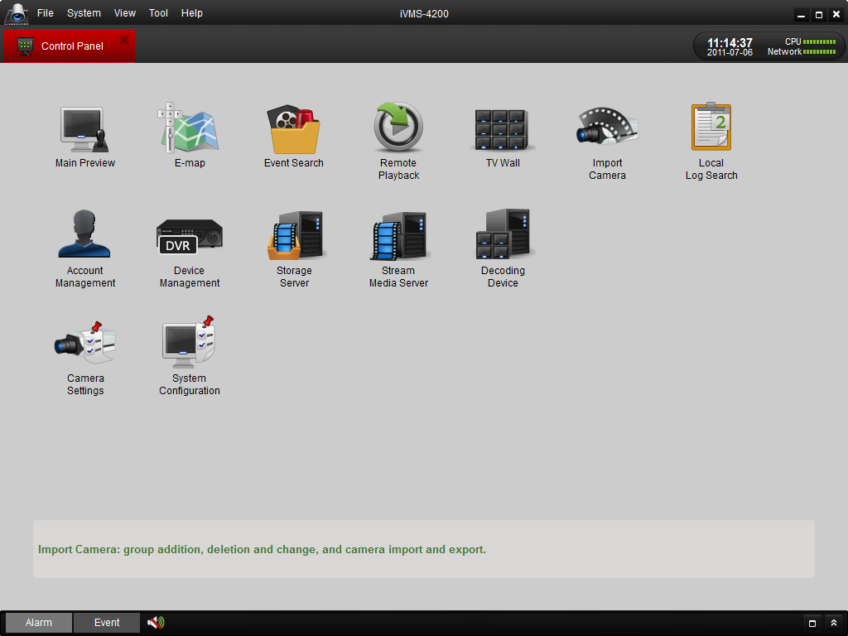
Figure 3.22 Control Panel

Menu Bar:
File | Open Captured Picture: | Enter the Capture interface to select the folder location of the exported captured picture file (s).
 | Open Video File: | Enter the video player and select the folder location of the exported video file (s), You can also capture pictures during the playing of the video file.
 | Open Log File: | Enter the Log File interface to select the folder location of the exported log file (s)
 | Exit: | Exit the iVMS-4200 remote client.
System | Lock: | Lock the screen operation. User must log in after locking the system.
 | Switch User: | Switch login user.
 | System Configuration: | Enter the System Configuration interface.
 | Import Configuration File: | Import client configuration from your computer.
 | Export Configuration File: | Export client configuration to your computer.
View | 1024*768: | Display window at 1024*768.
 | 1280*1024: | Display window at 1280*1024.
 | Full Screen: | Display window in full screen.
 | Control Panel: | Enter Control Panel.
 | Main View: | Enter Main View interface.
 | E-map: | Enter E-map interface.
 | Event Search: | Enter Event Search interface.
 | TV Wall: | Enter TV Wall View interface.
Tools | Import Camera | Enter Import Camera interface.
 | Camera Settings | Enter Camera Setting interface.
 | Account Management | Enter User Account Management interface.
 | Device Management | Enter Device Management interface.
 | Storage Server Management | Enter Storage Server Management interface.
 | Stream Media Server Management | Enter Stream Media Server Management interface.
 | Decoding Device Management | Enter Decoding Device Management interface.
 | Broadcast | Select device to start broadcasting.
Help | Open Wizard | Open the guide for camera import.
 | About | View information of the client software, including company, software name, version, etc.
 | Help | To get help about the FAQs.
 | User Manual (F1) | Click to open the User Manual; you can also open the User Manual by pressing FI on your keyboard.

There are 14 icons on the control panel, and their functions are described in the following table:

Operating  Options | Main View | View live and playback video; realize video operation (e.g., picture capture, recording, PTZ control, etc.).
 | E-map | Manage and display E-Map and hot spots; realize E-Map operation (e.g., operate map zoom in/out, view hot spot, display alarm, etc.)
 | Event Search | Search and playback of the event record files; realize playback operation.
 | Remote Playback | Playback the recorded video and/or audio files in the remote client.
 | TV Wall | Configure and operate TV wall.
 | Import Camera | Add, modify or remove the groups; import/export of cameras.
 | Local Log Search | Search, view and backup of local logs (alarm, operation, system logs).
Management Options | Account Management | Add, modify or remove the user account parameters; assign operating permission to each user.
 | Device Management | Add, modify or remove the DVR device; configure parameters (e.g., network, alarm input/output, HDD, etc.) for the added DVR.
 | Storage Server Management | Add, modify or remove the storage server; configure parameters (e.g., record schedule, network, HDD, etc.) for the added storage server.
 | Stream Media Server | Add, modify or remove the stream media server; configure parameters (e.g., RTSP port, port upper/lower limit, etc.) for the added stream media server.
 | Decoding Device | Add, modify or remove the decoder; configure parameters (e.g., network, alarm input/output, exception, etc.) for the added decoder.
Configuration Options | Camera Settings | Configure camera parameters (e.g., image quality, record schedule, motion detection, etc.).
 | System Configuration | Configure the general parameters (e.g., saving path of files, alarm sound, Email, etc.).

3.7 Account Management
Click to enter the following account management interface:
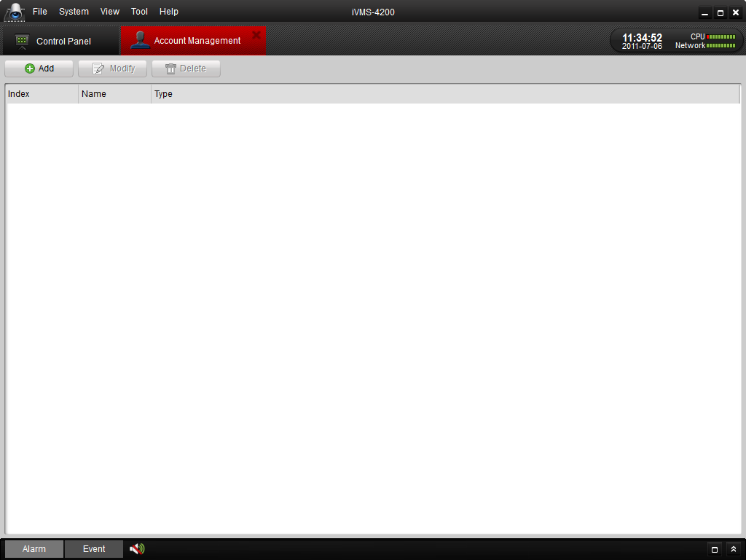
Figure 3.23 User Management

Click Add to enter the popup Add User dialog box as follows:

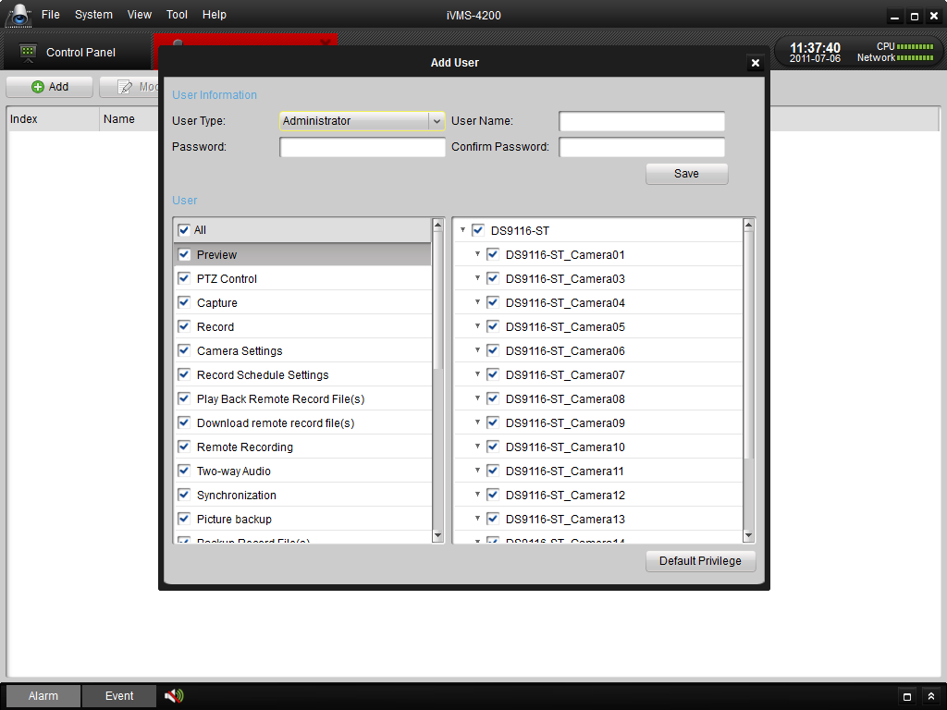
Figure 3.24 Add User
There are two parts of the dialog box of Add User: Basic Information and User Permissions.

Basic Information—provides two kinds of user types (Administrator and Operator) to support the users with different permissions.
User Permissions—include 26 optional permissions and provide manual selected permission function for the different users.
Note: The Admin user has all the permissions as default and operator user’s permission should be selected from list. All selected permissions will immediate take effect.
Input user name and password, and then click Save to add a new user. Click Modify to change the settings.

Chapter4. Adding Devices
Before any operation, you need to add a device and import cameras. Please refer to Section 3.2 Import Camera Wizard.
Click 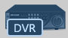 to enter the device management interface.

4.1 Adding Device

4.1.1 Adding Device
To add DVR device to the remote client, you click Add in the Device Management interface.
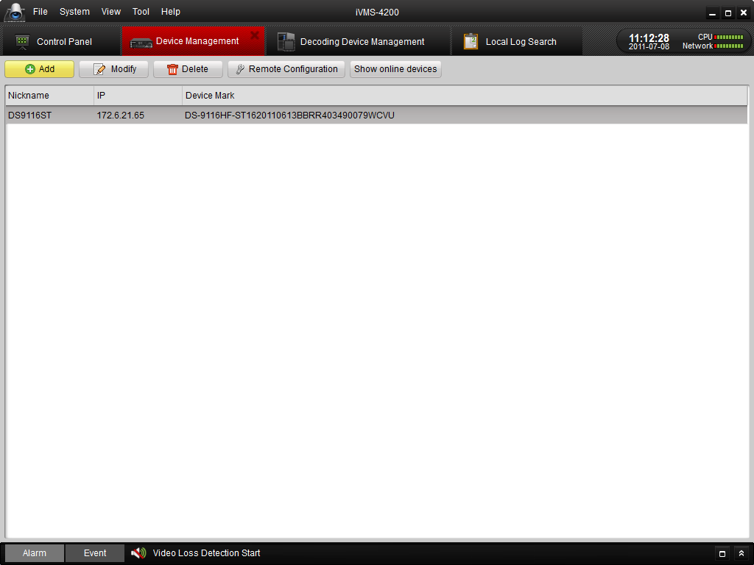
Figure 4.1 Add Device
Create a nickname for the device and then input it with other information, the User Name and Password are admin and 12345 respectively by default.
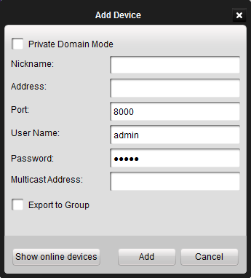
Figure 4.2 Add Device-pop-out

If you check the Private Domain Mode checkbox, you should input the DNS address and Device Mark (the device identifier) as well.
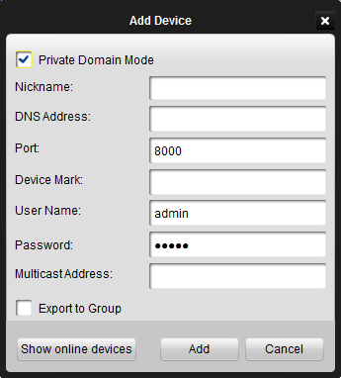
Figure 4.2 Add Device-Private Domain

Click the Show Online Devices icon to search the online devices. All the online devices will show in the list. Click to select the online device you want to add, and then click Select Device to add the device.
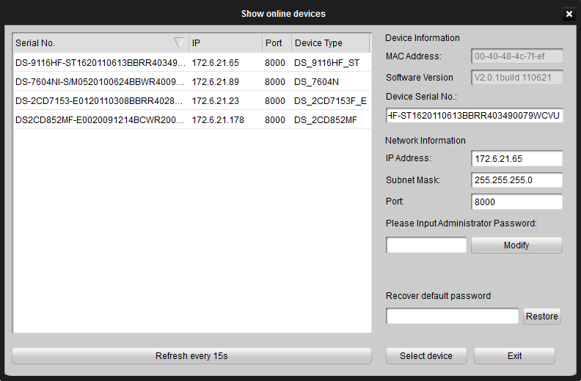
Figure 4.3 Add Online Device-Private Domain

4.1.2 Device Configuration
After adding the device, you can follow the procedure in this chapter to configure the device.
Click to select the device in the Device Management interface.
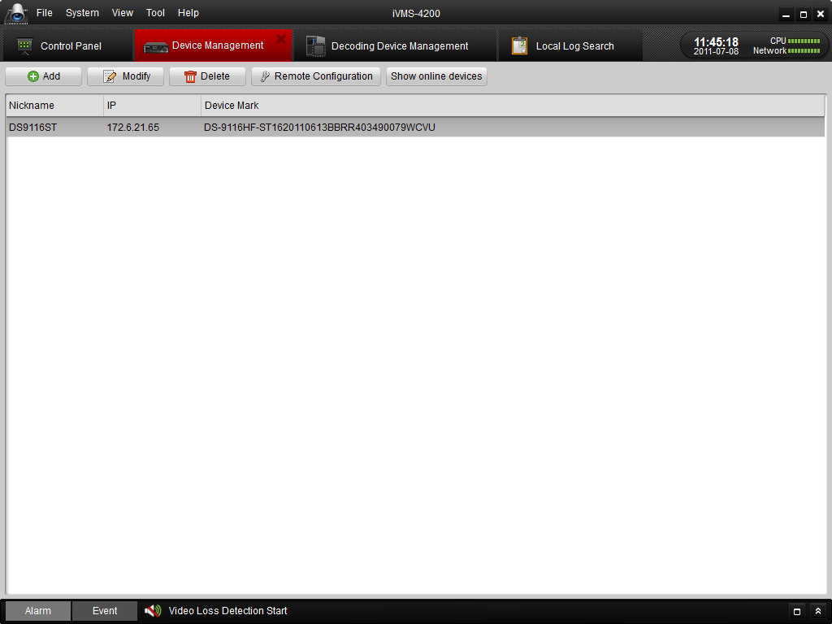
Figure 4.4 Configure Device

You can click Modify to edit the device basic information as device name and address.
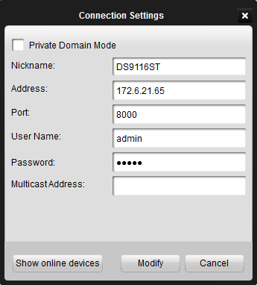
Figure 4.5 Modify Device

Click Delete icon to delete this device and you can also configure the settings of the device by clicking . For the detailed procedures of remote configuration, please refer to9.2 Device Configuration

4.2 Adding a Stream Media Server
Click 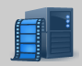 to enter the Stream Media Server configuration interface.
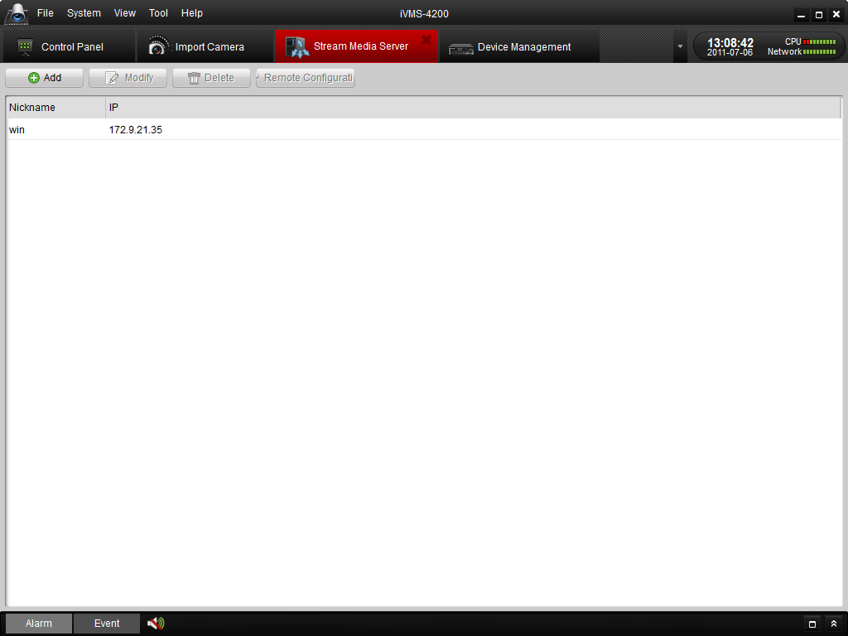
Figure 4.6 Manage Stream Server

And then click Add, the configure dialog box will pop up as below.
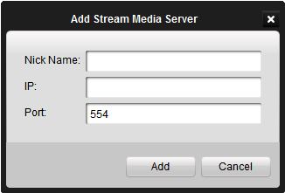
Figure 4.7 Add Stream Media Server
Input the Nike Name, IP address and Port (the Port 554 is the default RTSP number), and then click Add to save it.

Click Modify to change the Nick Name and IP address.
Click Delete to delete the Stream Media Server.
Click Remote Configuration to configure the SMS with RTSP Listen port, Port pool upper limit and Port pool lower limit.
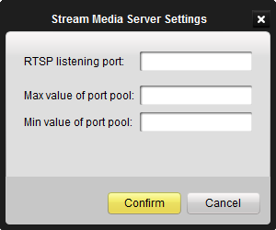
Figure 4.8 Configure Stream Media Server

4.3 Adding a Camera Group
After adding the target device, please return to the control panel interface and click Import Camera to enter camera group configuration interface (Figure 4.7).And then click Add to create a group in the right area (Figure 4.7, Figure 4.8). Select the camera in the left area, and then click import or import all to add the cameras to the group. User can also hold the Ctrl key and select multiple channels each time.

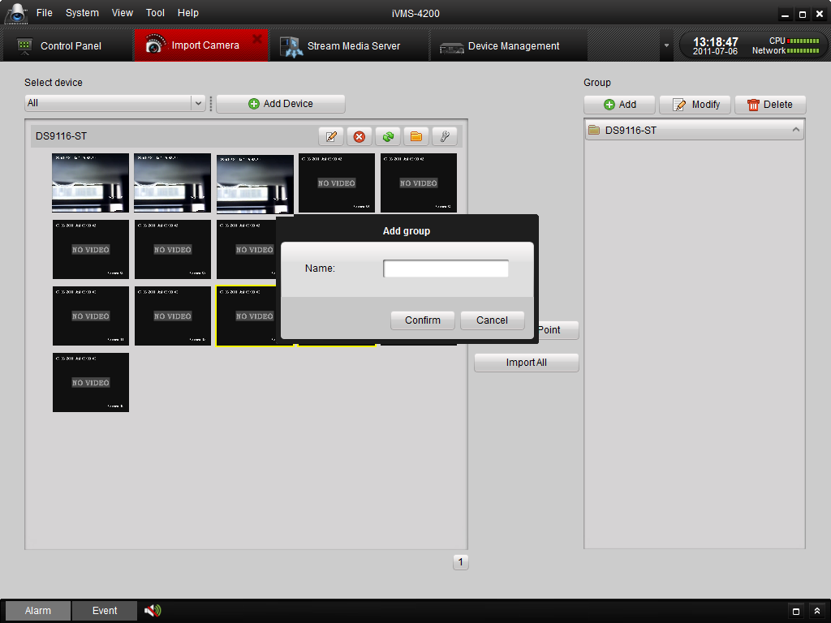
Figure 4.9 Camera Import - Add a Group
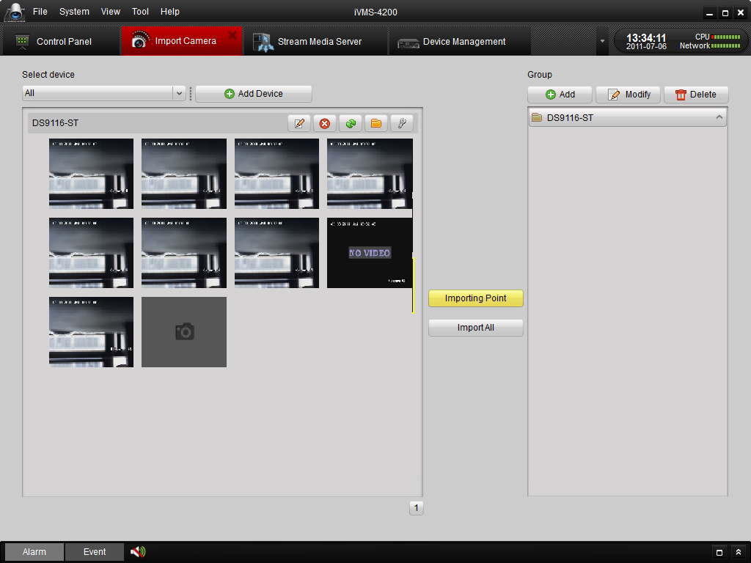
Figure 4.10 Camera Import –Completed
Click Delete to delete the added group or camera.
Click Modify to modify the group No. and camera’s information in the group.

Chapter5. Live View & Control
Note:
A camera group is required to be defined before live view. For the grouping operation, please kindly refer to chapter 4.3 Add a Group.

5.1 Main View Interface
Please click the icon “Main View” of the control panel, or click View -> Main View on the toolbar to start live view.
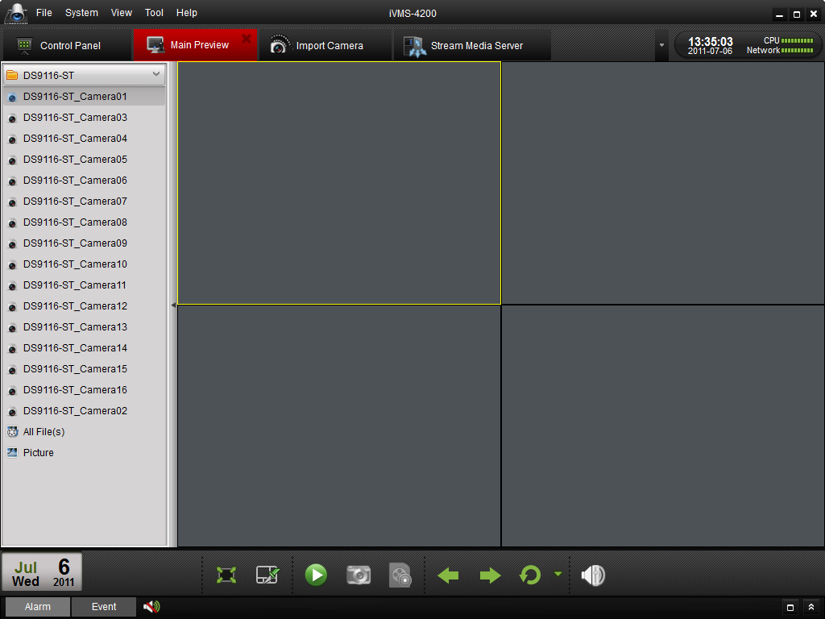
Figure 5.1 Main View Interface
Icons in the camera list:

Icon | Description
 | Camera is connected and works properly.
 | Camera is not connected.
 | Camera is in preview.
 | Camera is recording.

Main View Toolbar:

Button | Name | Description
 | Layout | Select different layout mode.
 | Full Screen | Display video in full screen mode, click again to restore.
 | Close All | Stop the display of all cameras.
 | Manual Record | Start manual record for the corresponding cameras, click again to stop.
 | Previous and Next | Click to view previous and next camera.
 | Auto Switch | Start auto switching the screen by cameras or by groups.
 | Volume | Adjust the volume for live audio.
 | Live Audio | Enable/disable live audio.

5.2 Starting Live View
To view the live video, drag the camera from the list to the displaying window, or double click the camera name after you select one screen (Figure 5.2).
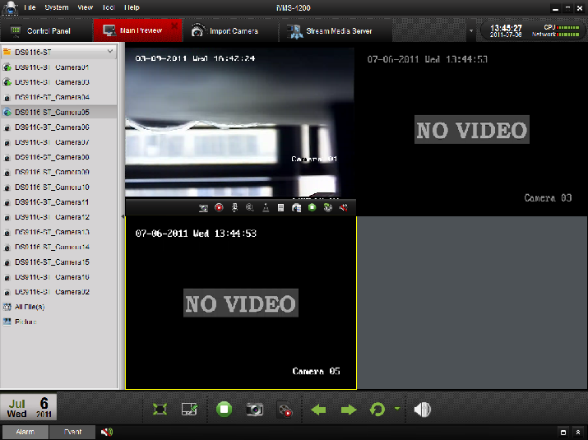
Figure 5.2 Start Live View
You can also get the live view for the whole group to display the live view of the cameras in the group in the screen. Click on the group name, and then click the Play button at the bottom of the screen, see the following figure.
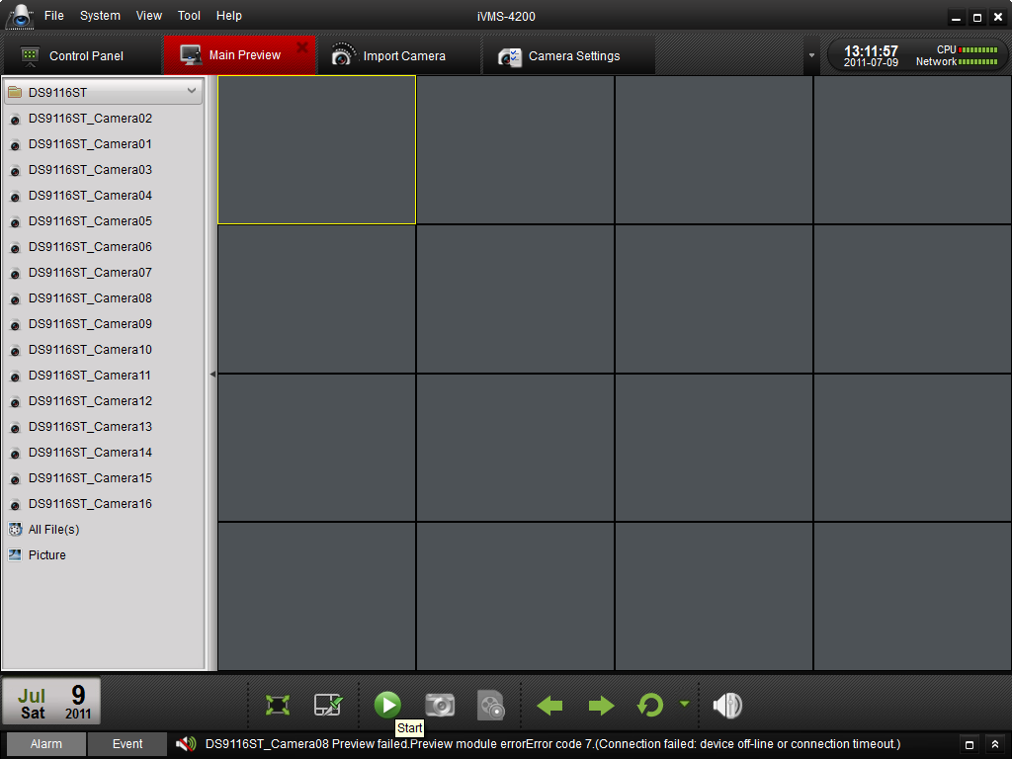
Figure 5.3 Live View for the Group
When you move the mouse to a small displaying screen, a small toolbar is showed up.
Toolbar in each display window:
Button | Description
 | Capture
 | Start manual record, click again to stop
 | Start voice talk, click again to stop. This two-way audio can be used for only one camera at one time. When you enable the voice talk of one camera, then the voice talk for other camera is stopped.
 | PTZ control, 8 direction icons will be displayed on the video.
 | Check the camera status
 | Go to the camera setting interface
 | Stop live view
 | Remote playback about 7 minutes record of current camera
 | Audio button, click to open and close

5.3 Capture in Live View
Steps:
- Move the mouse to the screen.
- Click icon on the bottom toolbar of Main View, or click icon in the tool bar of this display window.
A small window of the captured picture will be displayed to notify you if the capture is done or not.
If the capture is successful, there will be a link to the staving path of the pictures, and if the capture failed, there will be error messages accordingly.
To view the captured pictures:
- Click on the small window of the pictures showed on the right bottom after capture.
- Click the Picture icon on the left toolbar, all the pictures captured on the remote client are stored here.
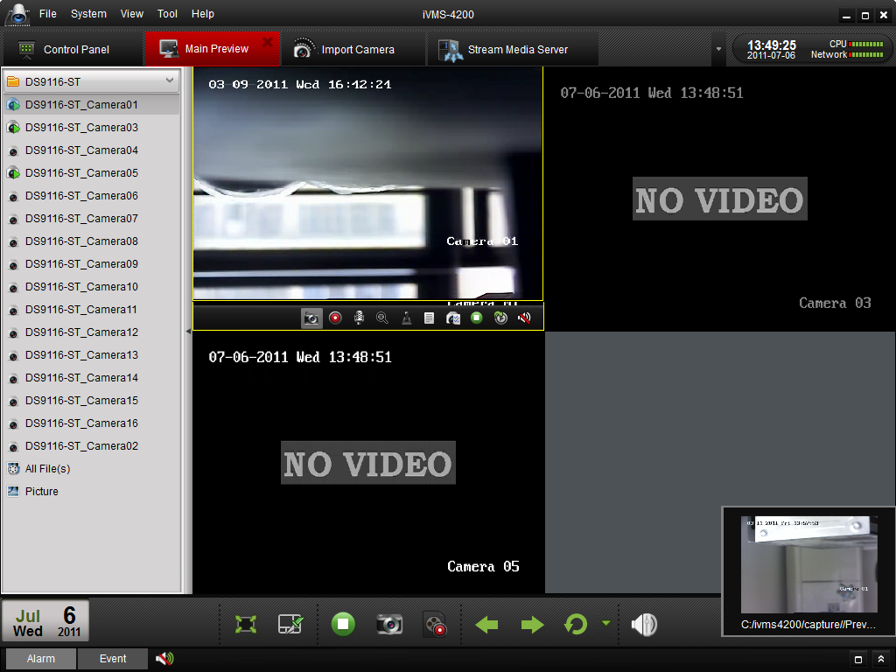
Figure 5.4 Capture in Live View

5.4 PTZ Control
For the PTZ control, click the icon on the toolbar on the screen for each camera, and the PTZ control panel will be displayed on the left side of the Main View.
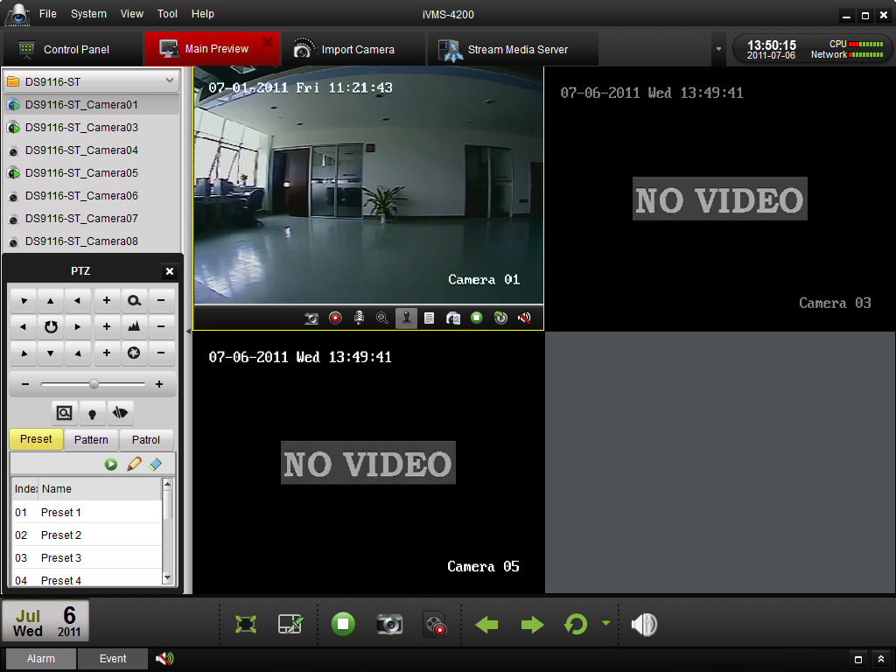
Figure 5.4 PTZ Control
There will be 8 directional buttons (up, down, left, right, upper left, upper right, bottom left, bottom right) on the display window when the mouse is located in the relative positions. Click on those directional buttons to control the PTZ function, or click the directional buttons on the PTZ control panel. You can also control the PTZ direction by the directional buttons on your keyboard.

You can control PTZ by dragging and clicking the mouse on the play window.
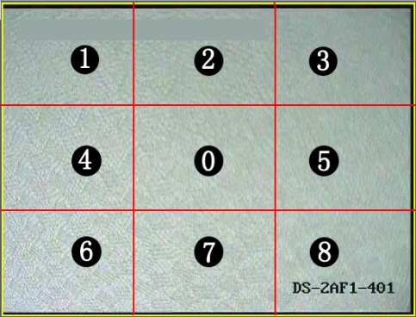
Figure 5.5 Soft Directional Control
Use the mouse to click on the video image, and then drag the mouse to different directions by following the arrows displayed on the video: Upper Left; Up; Upper Right; Left; Right; Lower Right; Down; Lower Right. The PTZ will move to the direction as the arrow goes.
Description of buttons on PTZ Control Panel:
Button | Description
 | Zoom
 | Focus
 | Iris
 | 3D Positioning
 | Light
 | Wiper
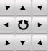 | Directional buttons, click to start/stop auto-scan.
 | Speed adjustment for PT function
 | Preset configuration
 | Pattern configuration
 | Patrol configuration
 | Call preset
 | Add preset
 | Delete preset

5.4.1 Preset
To add a preset for the PTZ:
- Click the directional buttons to move the PTZ to a desired location,
- Select a PTZ preset number from the preset list, and then click to add the preset and name this PTZ preset (Figure 5.6).
To delete a preset, select the PTZ preset from the preset list, and then click to remove it.
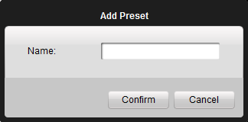
Figure 5.6 PTZ Preset

5.4.2 Pattern
To add a pattern for the PTZ,
- Click the button to enter the PTZ pattern path setup panel (Figure 5.7).
- Select a PTZ pattern path number from the pattern list, click to enter edit mode.
- Click to start recording of this pattern path.
- Use the directional buttons to control the PTZ movement.
- Click to stop pattern recording. Click to save the pattern path.
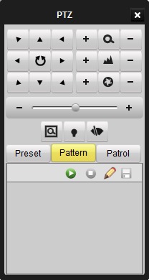
Figure 5.7 PTZ Pattern

5.4.3 Patrol
After adding two or more presets for one channel, you can set a patrol with presets for PTZ.
To add a patrol path for the PTZ,
- Click the button to enter the PTZ patrol path setup panel (Figure 5.8).
- Select a track number from the list,
- Click to add a preset (including the dwell time and PTZ speed for the preset) for this patrol path (Figure 5.8).
- Click to call the patrol path or click to stop calling.
- Click to edit a preset in the patrol path.
Note:
- Up to 16 patrols can be configured.
- The patrol time can be set to 1~255 sec, and the patrol speed to level 1~40.
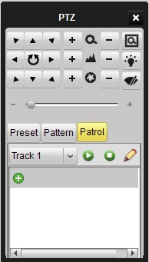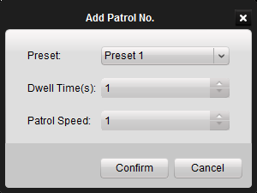

Figure 5.8 Add preset to patrol path

Repeat the above operation to add other presets to the patrol.
After configuration, you can choose the patrol from the drop-down list, and then call or stop them by clicking or key.

5.5 Alarm / Event View

5.5.1 View Alarm /Event Information
The Main View interface provides theand buttons at the left bottom. Click the button to view the alarm or event information as shown in the panel. You can click icon to show the alarm/event log list or click to hide the list. Refer to Figure 5.7.
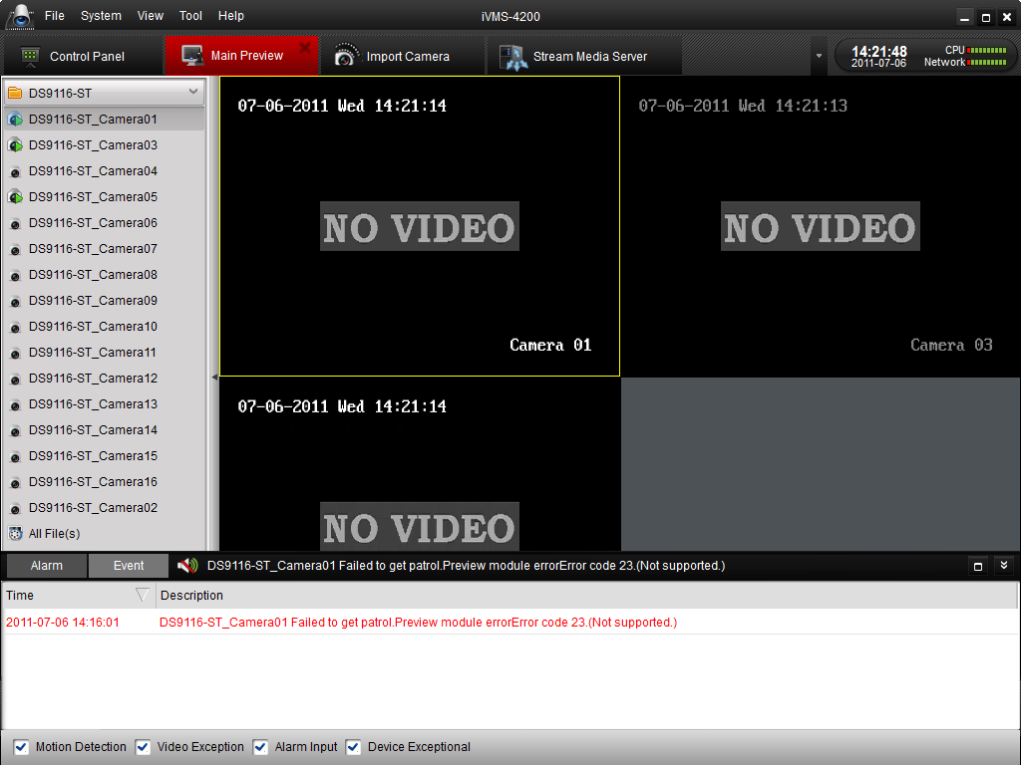
Figure 5.9 Alarm Log
Click icon to maximize the alarm/event log display panel and enable it to be shown in a new tab page.
Click the 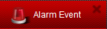 button at the top to close tab page. Refer to Figure 5.8:
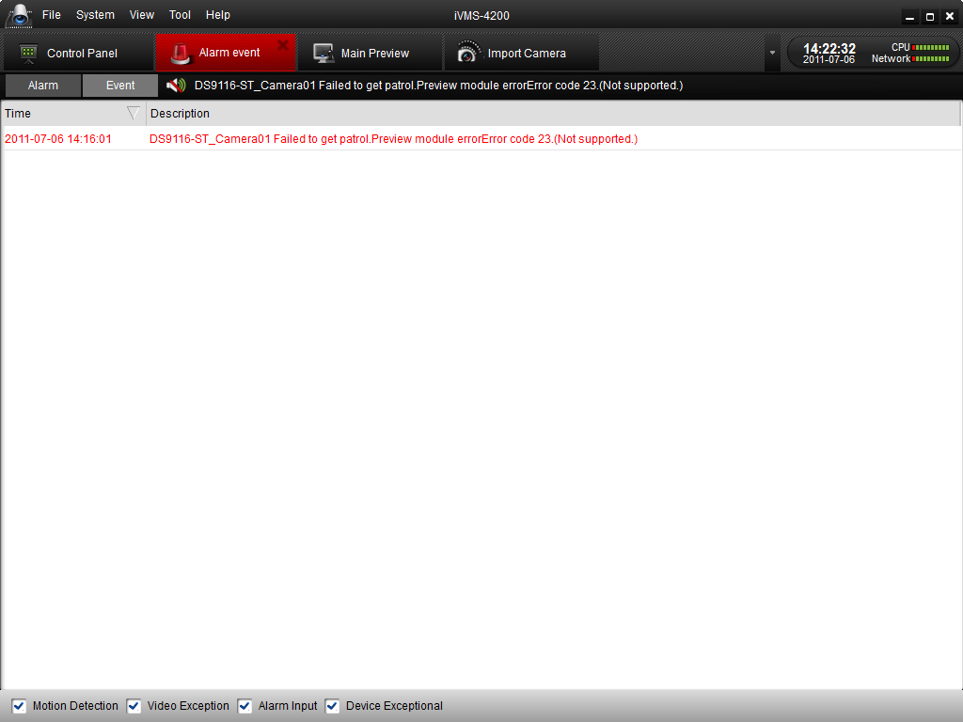
Figure 5.10 Alarm Log Tab Page

As shown above, in the alarm log display panel, there are 4 different alarm types: “Motion”, “Video Abnormal”, “Alarm Input” and “Device Abnormal”.
You can select a log and right click it to remove it from the list by right clicking the mouse and then click.
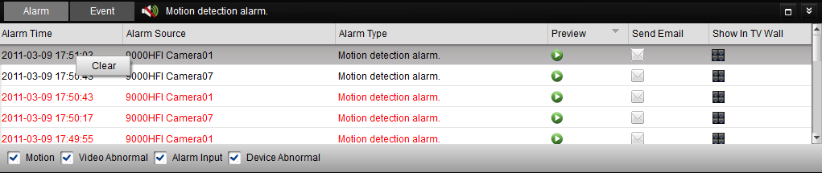
Figure 5.11 Clear Alarm Log

5.5.2 Alarm Log Linkage
Each alarm log has shown the related alarm information, including alarm time, alarm source and alarm type.
You can click the, or button to preview, send email or shown in TV wall of the selected log video.

Preview: View the live video of the selected alarm source camera. Refer to Figure 5.10.
Send Email: Send the alarm information by Email.
Note: User needs to configure Email settings in Control PanelSystem ConfigurationEmail before using this function.
Shown In TV Wall: Enable the video from the alarm source camera be decoded and displayed on TV wall.
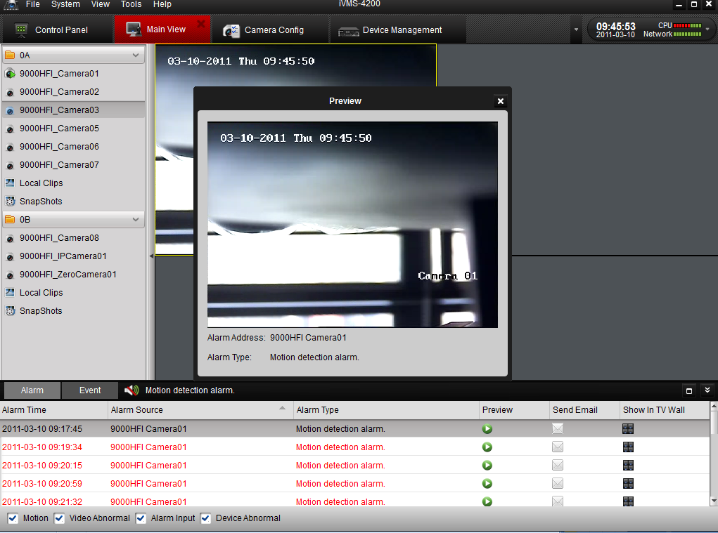
Figure 5.12 Alarm Log Linkage

Chapter6. Recording
iVMS-4200 software provides the local recording, and remote recording modes

6.1 Local Recording
Local Recording (also known as Manual Recording) function allows you to record the live video in the Main View mode. Please follow the steps to start local recording:
- Select a channel in the group and double click it to view the live video.
- Then click 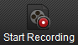 button at the bottom of main view panel to start to record the live video.
- When you wish to stop recording, please re-click 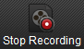 button to finish recording. A prompt box will pop up if all the operations succeed, as shown in Figure 1.
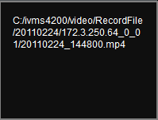
Figure 6.1 Local Recording Succeed

6.2 Storage Server Recording
Through iVMS-4200, you can configure the recording schedule for any added channels and store the recorded files in the NVR storage server.

6.2.1 Adding Storage Server
- While installing iVMS-4200 software, please select PC NVR Server as well to enable NVR software, as shown in the following figure below.
Note: NVR Server and the client software can be installed on different PC.
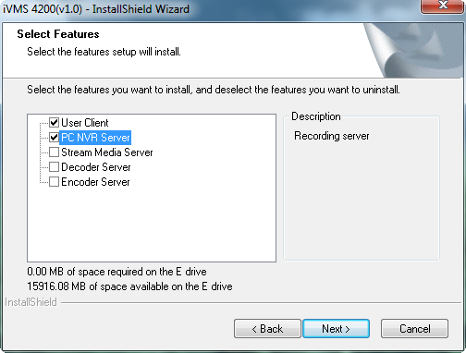
Figure 6.2 Install PC NVR Server
- Click 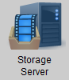 button in the Control Panel then click button to add the storage server.
- Create a nickname for the storage device and input with other information. 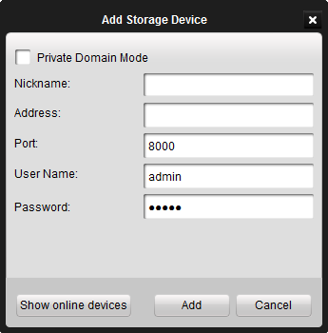
Figure 6.3 Add NVR
- After adding the device, click button and go to HDD sub-menu and select a local HDD in the server for storing recorded files, then click button to format the HDD, shown as figure below:
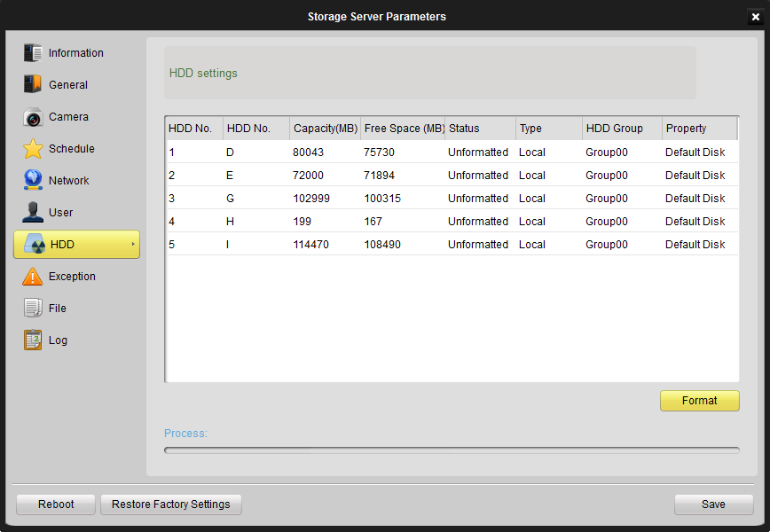
Figure 6.4 Format HDD

6.2.2 Setting Storage Server Recording Schedule
Steps:
- Add Recording Channels: Go to Camera sub menu of the Remote Configuration.
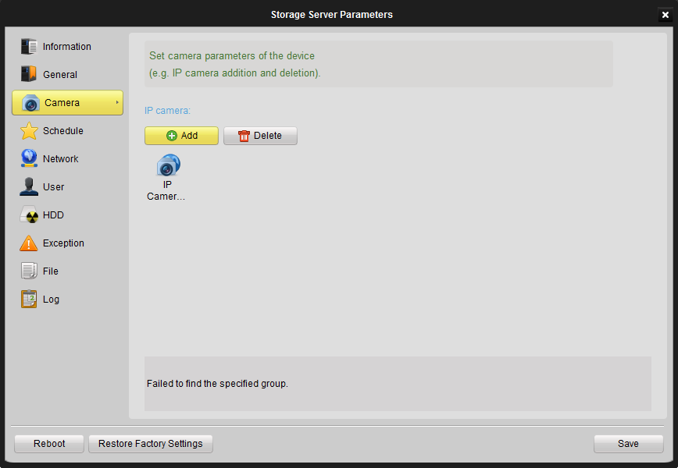
- Clickbutton and select a channel from the group, shown as figure below. You may also remove or get the channel information by clicking Delete buttons.

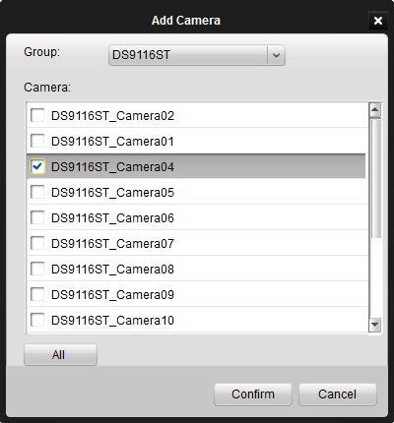
Figure 6.5 Add Channels

- Set Recording Schedule: click Schedule on the left to enter schedule configuration interface.
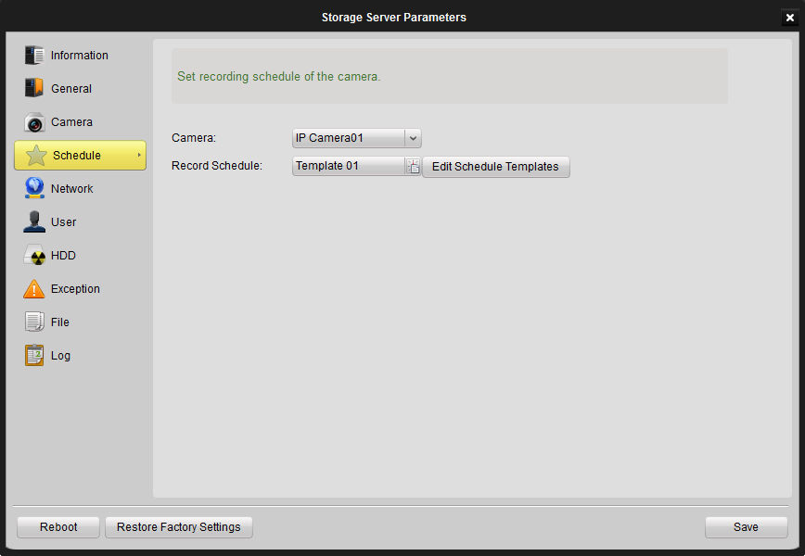
Figure 6.6 Configure Recording Schedule

- Select the camera from the dropdown list, then click Edit Schedule Template icon and configure the schedule template shown as below:
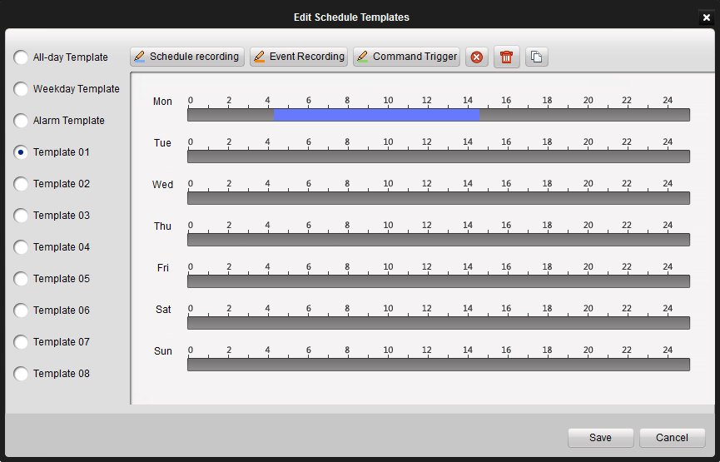
Figure 6.7 Schedule Templates

- All-day Template for all-day continuous recording,
- Weekday Template for working-hours continuous recording from 8:00 AM to 8:00 PM;
- Alarm Template for all-day event recording) and 8 customized templates.
Toolbar Description:
means normal scheduled recording. The schedule time bar shows blue.
means schedule recording for events. The schedule time bar shows yellow
means schedule recording triggered by command. The schedule time bar shows green.

Note:
- If you want to change recording resolution, bit rate or other recording parameters, please click Image Quality button in the Camera Settings panel and modify the main stream quality as needed.
- To ensure that event recording works properly, please set motion detection &video tampering area, schedule/alarm schedule first and then enable trigger camera recording. More details in Camera Settings Chapter.
- Command recording function is only available when iVMS-4200 added ATM DVR while the ATM transactions are taking place.

6.3 Remote Recording
When the video storage devices are HDDs, NetHDDs or SD/SDHC cards installed in the DVR or IP cameras, you may adopt remote recording mode as well.
- Format the HDD or SD/SDHC card: After adding the devices into iVMS-4200, enter the Device Management interface and then HDD sub-menu to format the storage devices first, shown in the figure below.
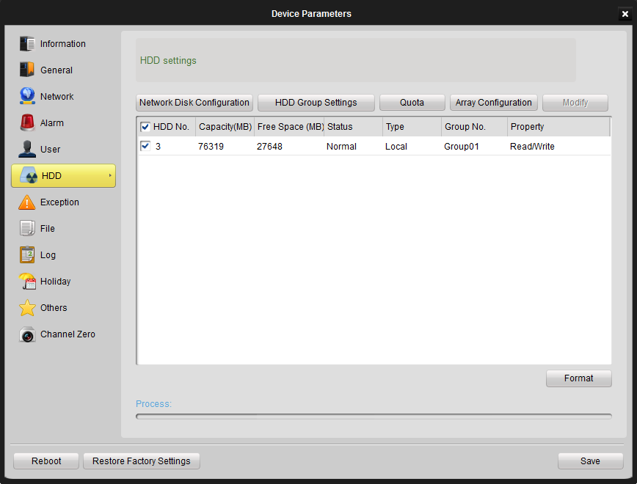
Figure 6.8 Format the HDD

- Enable Local Recording: Go to Camera Configuration Panel and tick Local Recording of the Schedule tab.
Note：Here the Local Recording refers to the recording on the DVR or IP Camera.

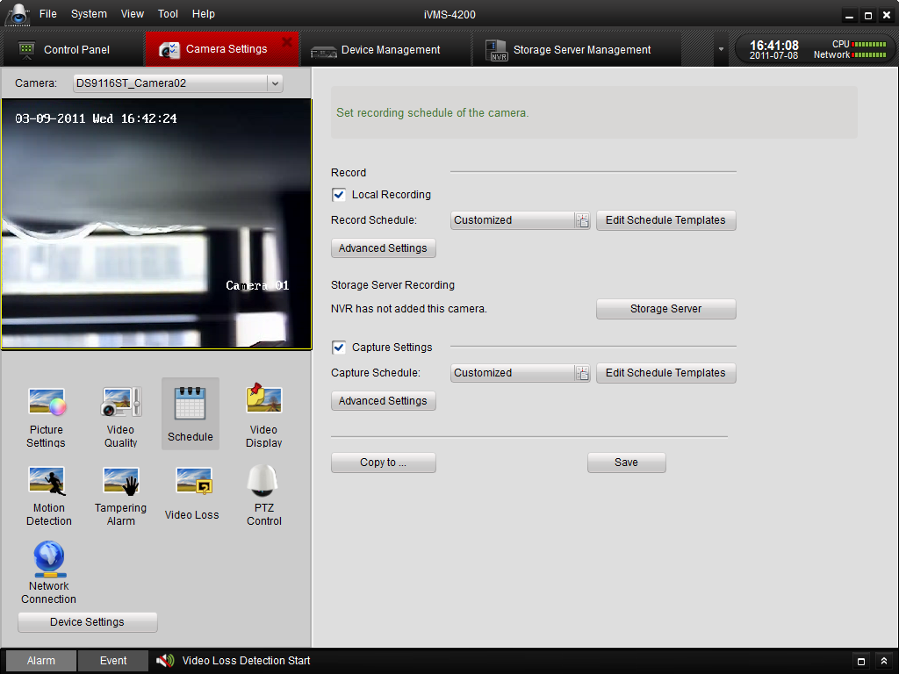
Figure 6.9 Enable Local Recording

- Recording Schedule Setup: After enabling the Use DVR option, please click Edit Schedule Template and select a recording schedule from the templates shown as below, please refer to previous chapter for schedule setting procedure.
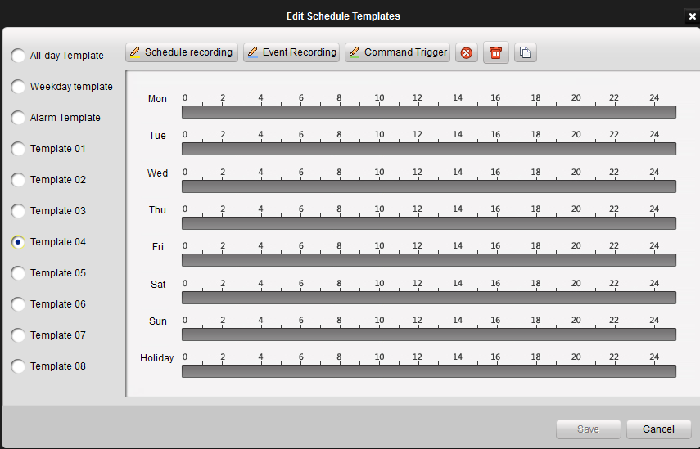
Figure 6.10 Recording Templates

Chapter7. Playback
Based on the different recording modes, the playback function consists of three playback modes: Local playback and Event Playback.

7.1 Playback of Local Stored Files
Play back the video files created in local recording mode.
- Go to Main View panel and click the All Files icon to enter the Local Record Files interface. Select a camera and specify the start time and the stop time, and then click Search button to search the video clips. The matched video found will be listed in the display panel below. Refer to Figure 7.1:
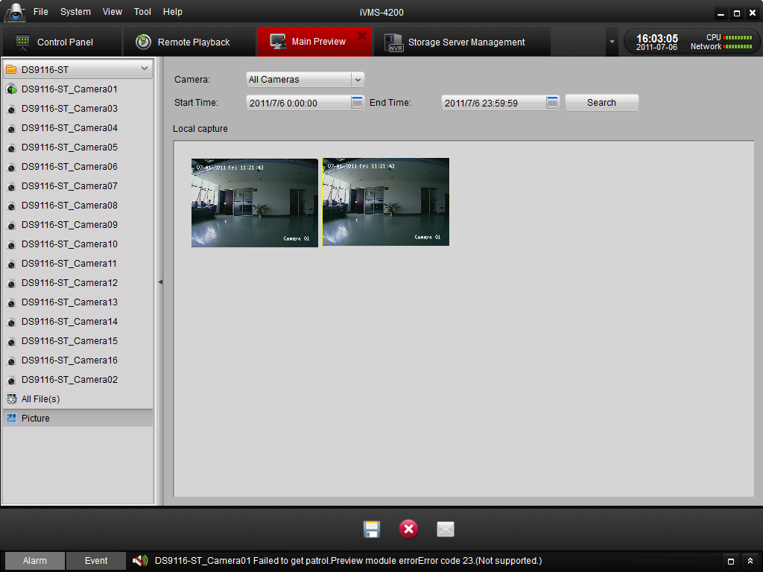
Figure 7.1 Search Local Record Files

- User can click 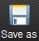 button to save the selected video clip. User can also click 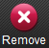 to delete the clip from the panel, or click the 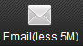 button to send the selected video clip by Email (size of video clip must be less than 5M).

- Select a video clip and double click it, and then a player will pop up (refer to Figure 7.2).
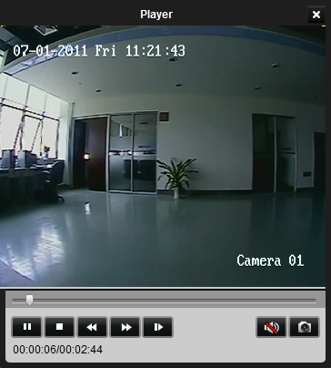
Figure 7.2 Playback Player

You can click icon to view the video, click and icons to fast or slow play the video. Click to pause the playing. You can also capture in the playing video.

7.2 Instant Playback
- Go to Main View panel, double-click a channel to enable the tool bar shown as below, and click button to start instant playback.
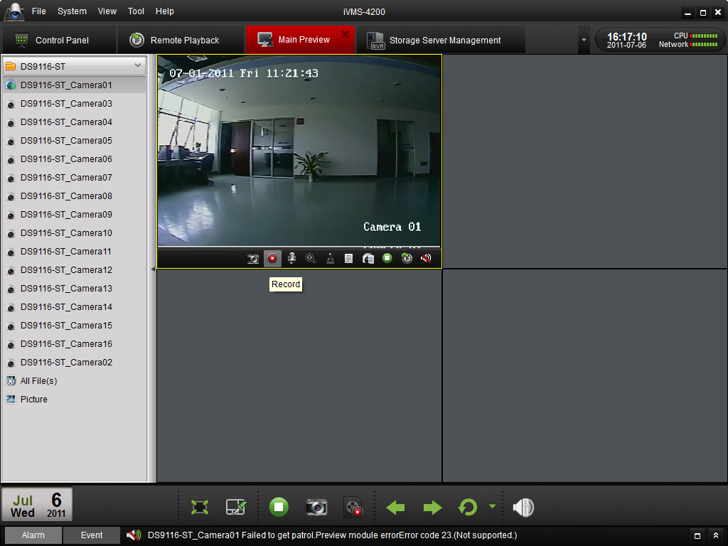
Figure 7.3 Switch Live Preview/Playback Mode
- In instant playback interface, please click button to start playback the first video files of current day; click and buttons to fast or slow play the video. Click to pause.
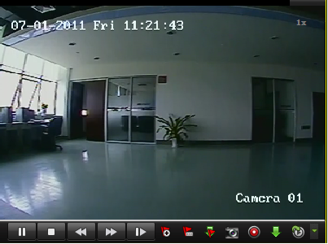
7.4 Playback Player

- The table below is a list of other buttons in this interface for video management.

Button | Description
 | Picture capture
 | Start/Stop video cutting
 | Download the video file with flow control
 | Switch preview/playback mode
 | Open/close audio
 | Add default tag
 | Add customized tag
 | Tag download

- You may also use the timeline at the bottom of the Main View panel to adjust the playback progress. Also and buttons are used to expand and narrow down the time bar so user can choose a more accurate playback time.
Figure 7.5 Time Bar

7.3 Event Playback
Playback the record files of event type.
- Go to Event Search interface and select an event type: motion or alarm input.
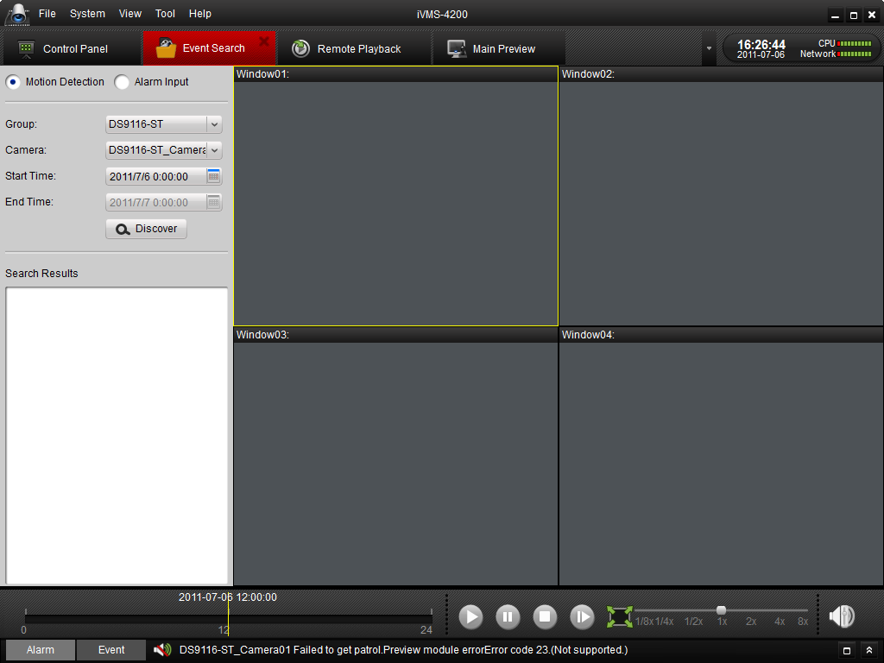
Figure 7.6 Event Search

- Select a camera in the group and specify a start time, then click Search button.
- Select a window, and double-click a video file from the search results list to play.

- During playing back the video, you may right click the mouse in the image to get a drop-down menu as shown in Figure 7.7. Please refer to the table below for more details on this menu. You may also change playback speed by clicking on the 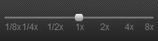 bar.

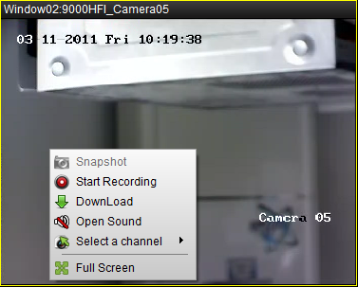
Figure 7.7 Event Playback

Button | Description
 | Picture capture
 | Start/Stop the video cutting
 | Download the video file
 | Audio button, click to open and close audio
 | Select a recording-triggered channel for playback
 | Full screen

Note:
- Event playback function is only available for NVR/DVR which support event recording.
- Make sure to import all the channels that you wish to play back in Import Camera panel.
- It is also required to enable continuous recording on all the alarm/motion-triggered channels before event playback.

7.4 Remote Playback
The remote client can search the record files on the Storage Server and the DVR, and it can also do the dynamic analysis for the record files.
Click 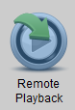 on the control panel to enter the Remote Playback Interface.
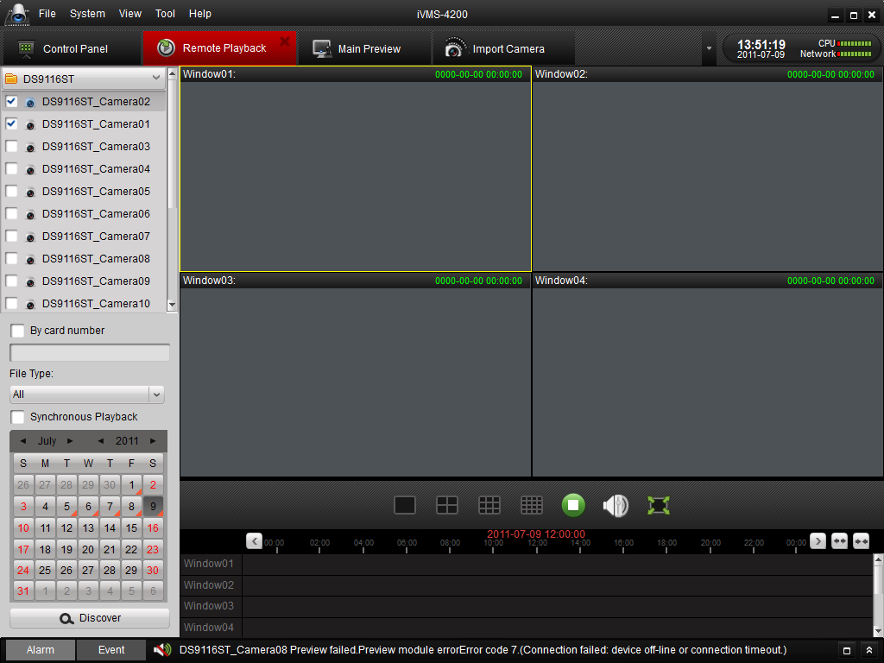
Figure 7.8 Remote Playback
Keyboard Description:
Icon | Name | Description
 | Screen Split | 1、4、9、16 screen-mode
 | Stop | Stop all the playback
 | Volume | Adjust volume
 | Full-screen | Full-screen Preview

Search the record files:
- By date and camera:
Check the checkbox on the camera list, and then on the calendar below, select the day you want to search. Then click Search.

Note: If there are record files for that camera in that day. In the calendar, the icon for that day is displayed as . Otherwise it is displayed as .
The timeline indicates the time duration for the record file.
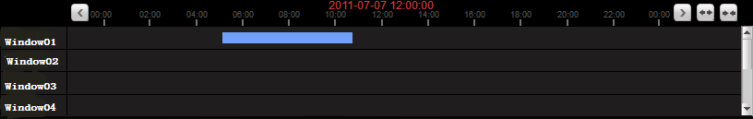
Figure 7.9 Playback Timeline
- By card number:
This function is only applied to the ATM DVR, you can search the record files by the DVR card number.
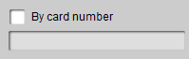
Figure 7.10 Search by Card Number
Note: You still need to choose the date and camera to search the files.
- By File Type:
You can select the file type to restrict the searching condition and search for only the record files for certain types.
Figure 7.11 Search by File Type
Playback Management:
After finding the record files, you can see the files displayed on the screen playing automatically.
- Move the mouse to the screen of which camera you’d like to manage. A toolbar is showed at the bottom.
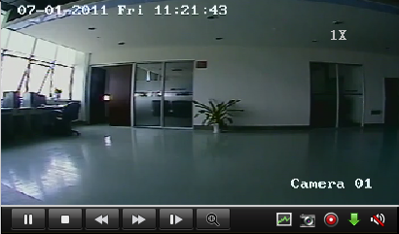
Figure 7.12 Playback Toolbar
Toolbar description:
Icon | Description
 | Pause the video
 | Stop playing
 | Playback by single frame
 | Dynamic Analysis
 | Clip
 | Audio on/off
 | Play
 | Speed Control
 | Digital Zoom
 | Capture in the playback mode.
 | Download
Note: Click , the video move forward to next frame.
You can enable audio on only one channel at one time.

Dynamic Analysis Management:
Click on the toolbar, the dynamic analysis toolbar is showed up.
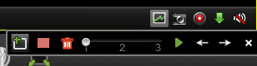
Figure 7.13 Dynamic Analysis
Note: The dynamic analysis function is applied to 9000 or 9100 series or upper version DVR.
Toolbar Description:
Icons | Description |  | Icons | Description
 | Draw Area |  |  | All Area
 | Delete Area |  |  | Sensitivity of Event
 | Start Searching |  |  | Last Event
 | Next Event |  |  | Close

If there are eligible record files for dynamic analysis, there are red areas on the time line.
Figure 7.14 Dynamic Analysis Time Line

Download Record Files:
Click to download the files you selected.
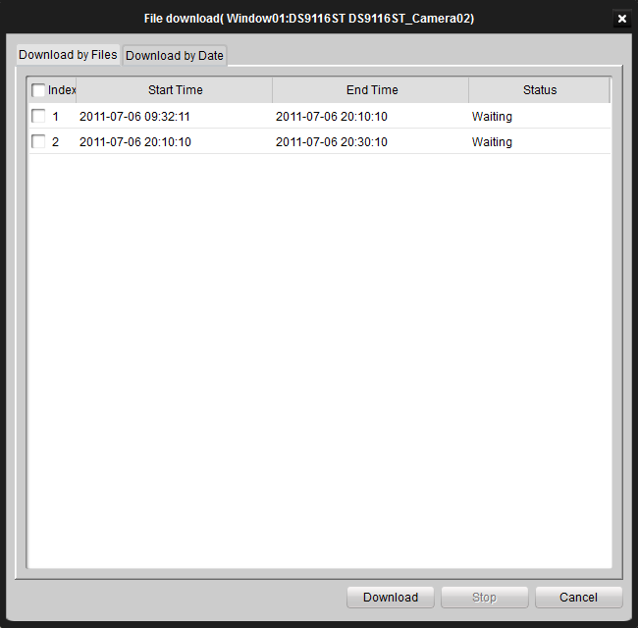
Note: The saving path for the downloaded files can be set in the System Configuration interface. See chapter 13.2.

Chapter8. Backup

8.1 Backup Captured Pictures
1. After configuring all settings, click 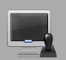 to enter the Main View interface (Figure 8.1). To preview the live video, drag the camera from the left list to the right display window.
Figure 8.1 Main View
- Click the 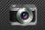 button to capture video picture in preview mode and a snapshot window will pop up at the lower right corner as shown in Figure 8.2.

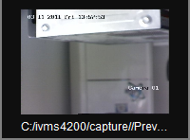
Figure 8.2 Captured Pictures
3. Double click the popup picture window to maximize it (Figure 8.3), on which it shows the default saving path of the captured pictures.
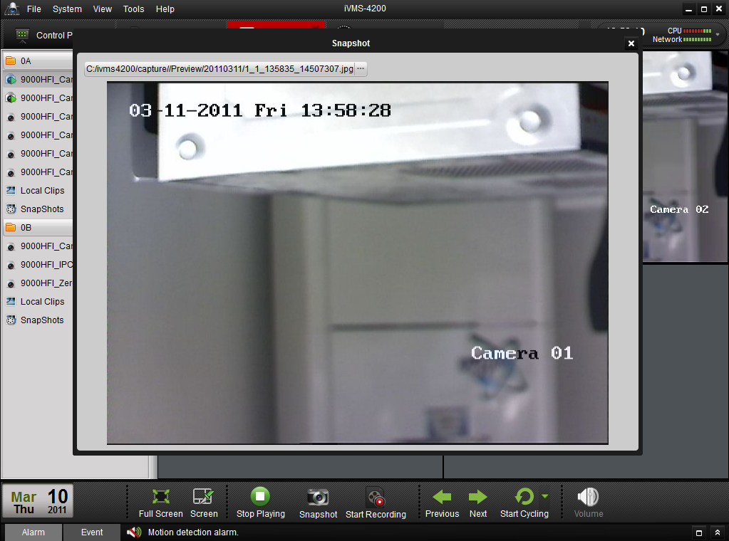
Figure 8.3 Maximize Captured Picture

- You can also save the picture by clicking the Picture icon on the left bar, select the picture you want to save and then click button in the Picture interface.

8.2 Record Files Backup
- Go to Main View interface and click the All Files icon.. Select a camera and specify the start time and the stop time, and then click Search button to search the recorded files. The files found will be listed in the display panel below. Refer to Figure 8.4:
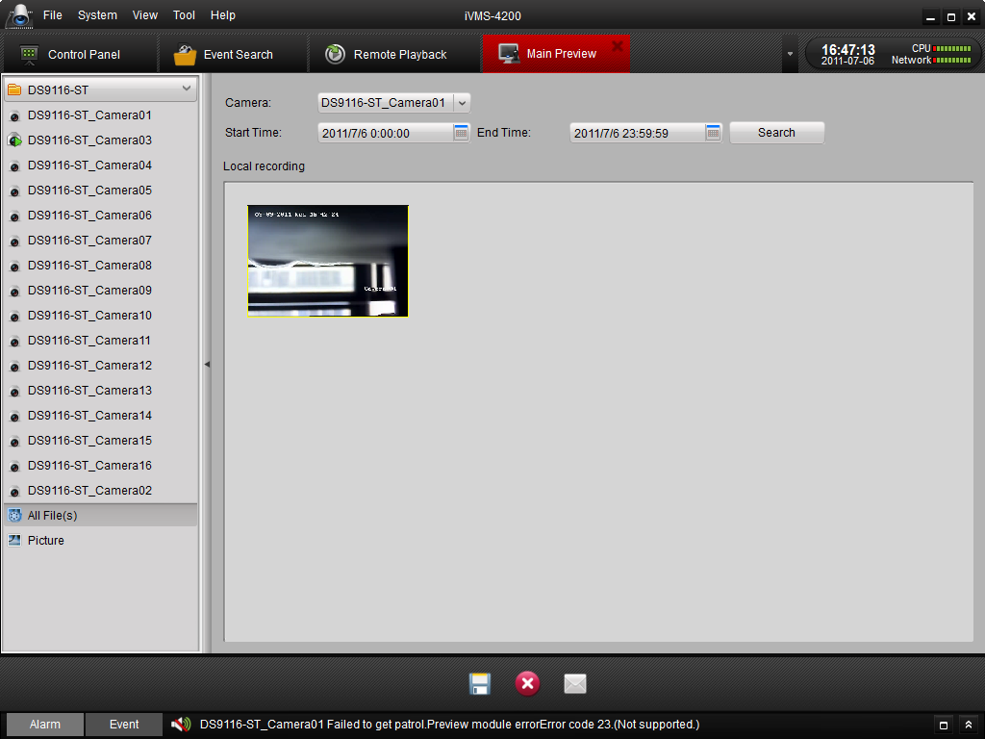
Figure 8.4 Search Local Record Files
- Click the button to back up the selected files.
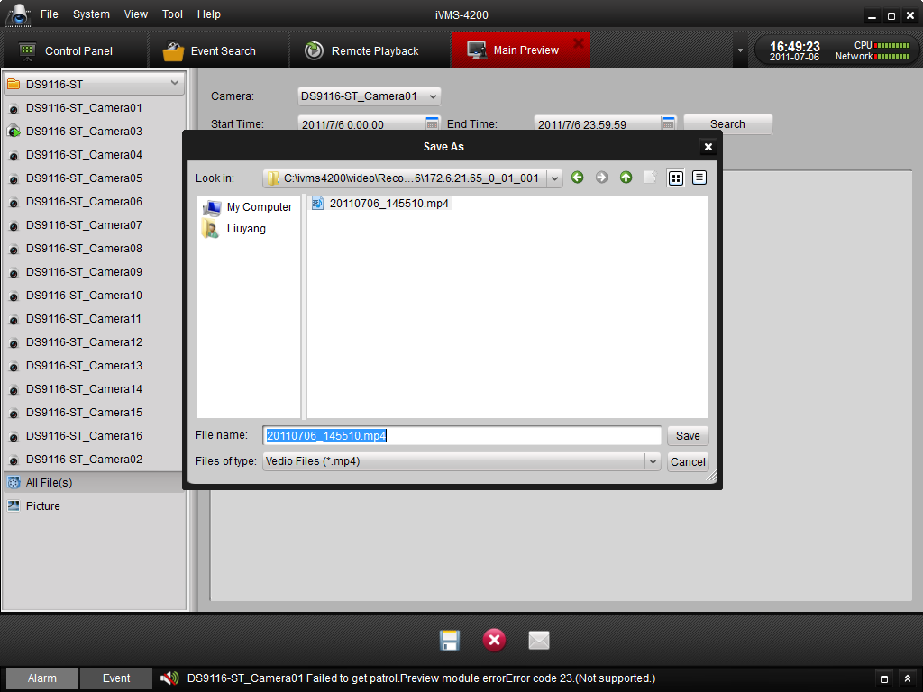
Figure 8.5 Save Local Record Files
User can also click to delete the clip from the panel, or click the button to send the selected video clip by Email (size of video clip must be less than 5M).

Chapter9. Camera & Device Configuration

9.1 Camera Settings
Click on the “Camera Configuration” icon 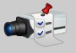 on the control panel to enter the camera configuration interface (Figure 9.1).
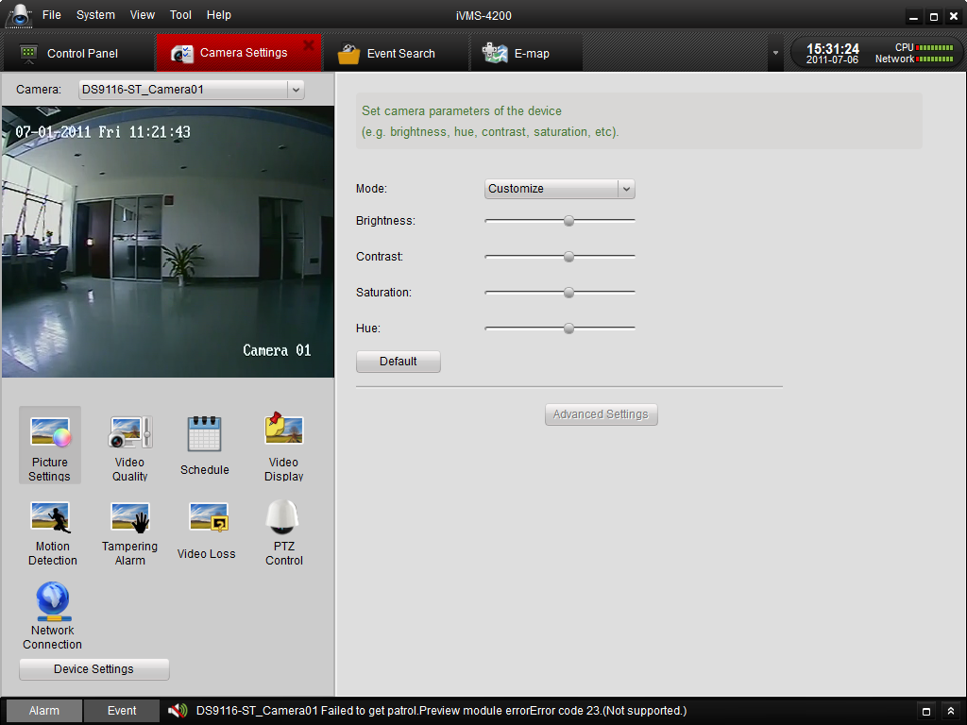

Figure 9.1 Camera Configuration

Select the camera on the upper dropdown list on left side of the interface, and the video image will be displayed in the screen below. Click on different icons in the bottom left area to enter different configuration pages. Click on the Device Settings icon and the relative device parameters will be displayed.

Button | Description
 | Video picture parameters configuration
 | Video encoding quality configuration
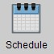 | Recording schedule configuration
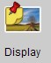 | Configure information to be displayed on the video
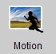 | Motion detect configuration
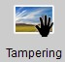 | View tampering alarm configuration
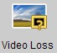 | Video loss alarm configuration
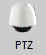 | PTZ Configuration
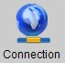 | Network parameter configuration for the camera

9.1.1 Image Quality
In the image quality configuration interface, you can adjust the brightness, contrast, saturation and hue of the video image (Figure 9.2). Drag the round icon to adjust the level from lowest to highest. There are several modes to be selected, including Standard, Mode 1, Mode 2, Mode 3 and Customize.
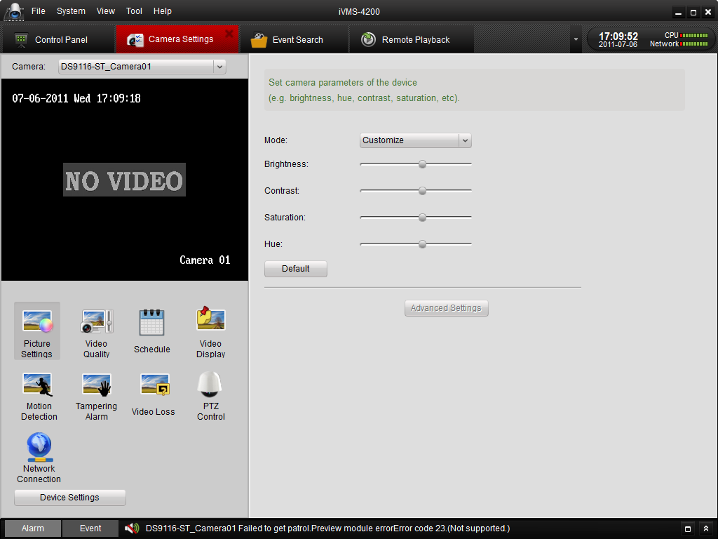

Figure 9.2 Image Configuration

You can click the Advanced Settings icon to enter advanced setting interface.
Click the Default icon to restore default settings.

9.1.2 Video Quality
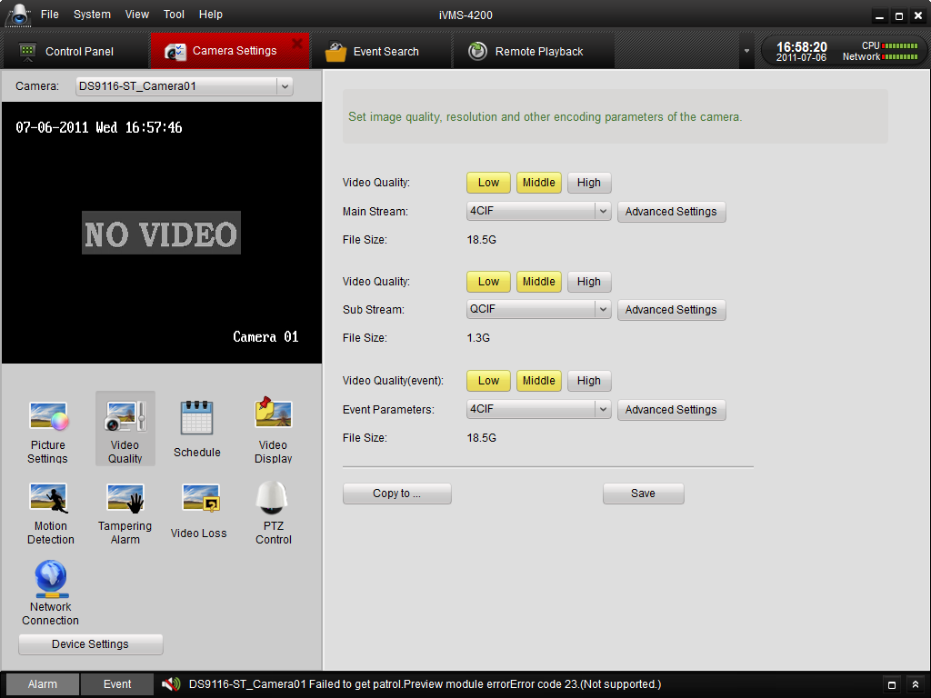
Figure 9.3 Video Quality Configuration

You can set video resolution and video quality for main stream and sub stream separately. Select the encoding resolution in “Main stream” or “Sub stream”, and click on the position of the block-indicators to select the appropriate video quality setting for the camera stream. You can click the Advanced Settings icon to enter advanced setting interface. 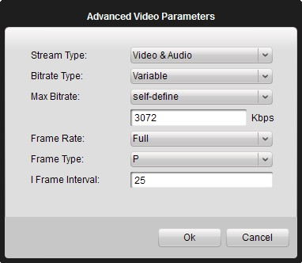
Figure 9.4 Advanced Video Parameters
Click Copy to icon to copy the settings to other cameras in the group.
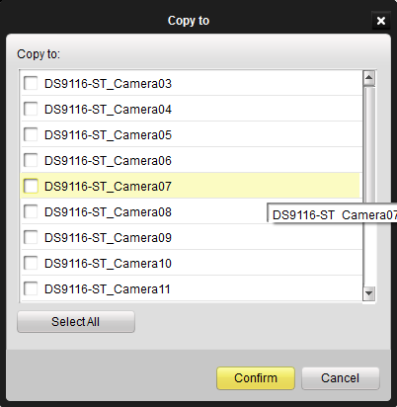
Figure 9.5 Advanced Video Parameters

9.1.3 Schedule
You can set different recording schedules in this interface. “Record” indicates that the recording schedule will be configured onto the device, and “Storage Server Recording” indicates that the recording schedule will be configured onto a Storage Server software. To assign an Storage Server for the recording schedule, please click Storage Server icon to add at least one server and then select the storage server from the list.
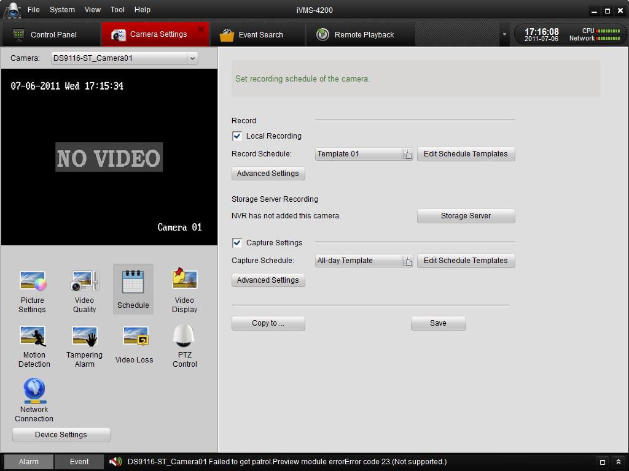
Figure 9.6 Schedule Settings
Click to enter Schedule Template setting page (Figure 9.6). Click on Schedule Recording, Event Recording or Command Triggered Recording to select different recording type to schedule a record, and then use the mouse to drag on each day’s time bar to configure the recording schedule.
Double click the colored (configured) time bar to get this time period and displays the scheduled time.
You can click to delete the selected schedule.
Click to clear all the record schedules.
Click to copy the selected schedule section to other day (s)

Click Confirm to save the changes.
Toolbar Description:
means normal scheduled recording. The schedule time bar shows blue.
means schedule recording for events. The schedule time bar shows yellow
means schedule recording triggered by command. The schedule time bar shows green.

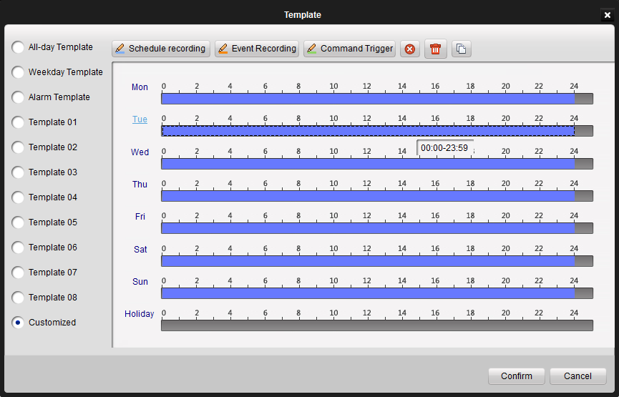
Figure 9.7 Edit Schedule Template

You can also copy the settings to other camera by clicking Copy to.
The schedule configuring procedure for the Capture Schedule is the same as configuring record schedule.

9.1.4 Video Display
1. The Display menu allows user to configure the display settings for the camera, including:
Display Name: the camera name displayed on the live video.
Display Date: the date displayed on the live video.
Display Week: Display the week on the live video.
Enable Privacy Mask: Enable privacy mask function on the live video.
Text Overlay: Edit user-defined text to be displayed on the live video.

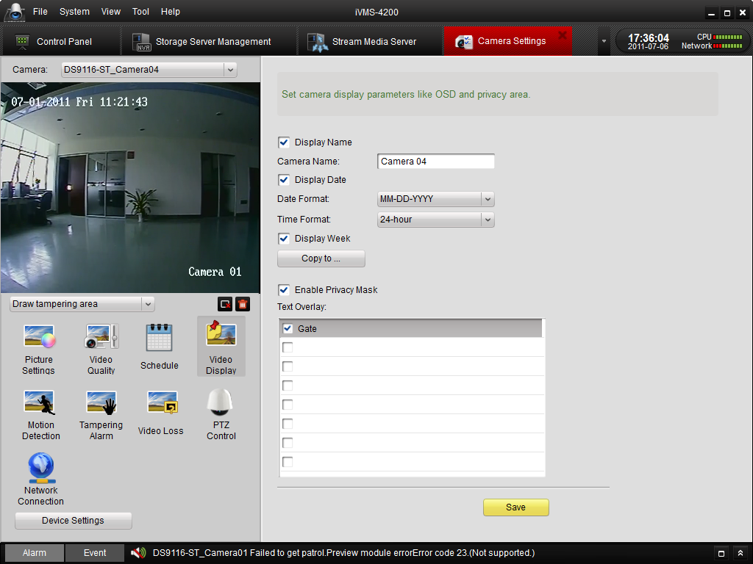
Figure 9.8 Video Display Settings
- To configure the user-defined text content, click the checkbox in the text box below and then input the characters.

- User can configure the OSD/text location and the privacy mask location & size on the video image.
- Select Draw OSD/Camera Name/text option from the drop-down list and then use the mouse the move the OSD to the desired location on the video image. Refer to Figure 9.9:
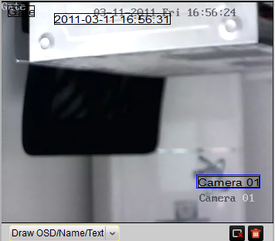
Figure 9.9 Configure OSD Location
- After having enabled the privacy zones function, select Draw Tampering Area option from the drop-down list to start drawing the privacy mask on the video image, and then use the mouse to move the privacy mask to the desired location or change the size. Please refer to Figure 9.10:
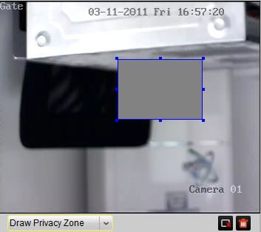
Figure 9.10 Configure Privacy Zone
- User can click the button to remove the selected privacy zone, or click to clear all privacy zones on the live video.
Note: No more than 4 privacy zones can be configured.
After all the display settings are completed, click to save the settings.

9.1.5 Motion Detection
You can configure Motion Detection related parameters by clicking the Motion Detection icon on the Camera Settings interface.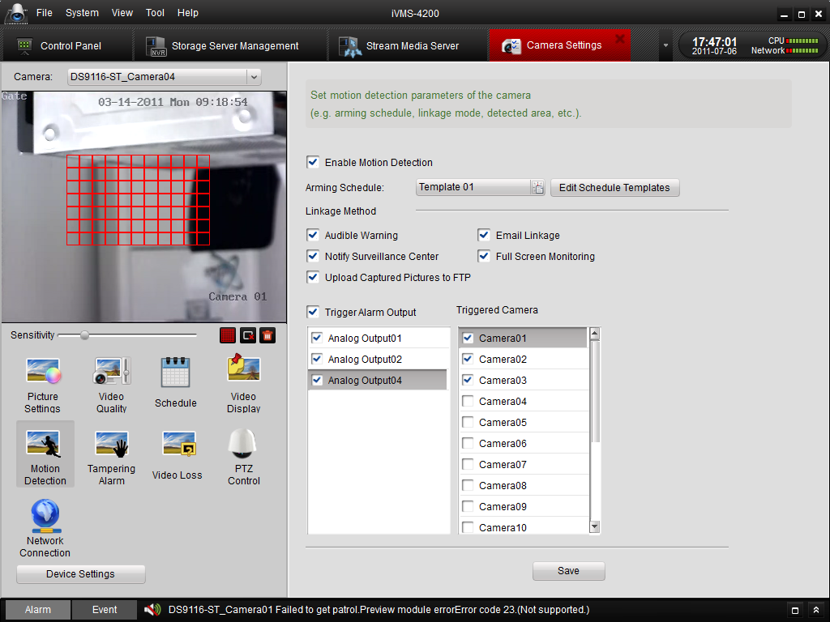
Figure 9.11 Motion Detection

Check the Enable Motion Detection checkbox.
Draw the motion detection area on the video image by dragging the mouse and set the sensitivity by moving the round icon on the sliding bar.
Click the icon to select the whole video area for motion detection.
Click the icon to delete the selected motion detection area
Click the icon to delete all the motion detection areas.
Schedule: configure the motion detection record schedule.
Linkage Method Description：
Audible Warning: trigger audible warning on the device when motion detection is triggered.
Notify Surveillance Center: upload alarm information to the CMS software when motion detection is triggered.
Trigger Alarm Output: activate 1 or multiple channels of alarm output when motion detection is triggered. Users need to specify the corresponding alarm output channel (s) in the alarm output channel list.
Upload Captured Picture to FTP: when motion alarm is triggered, several pictures will be captured and uploaded to FTP server.
Email Linkage: send an Email when motion detection is triggered. The email account settings are configured under the Device ManagementConfigNetworkEmail Settings.
Full Screen Monitoring: switch to full screen to monitor the motion detection video..
Triggered Camera: trigger motion detection recording on the camera. Please select the camera (s) that required to be recorded on the motion detection of current camera in the camera input list.
After all the motion detection settings are completed, click to save the changes.

9.1.6 Tampering Alarm
- Check Enable Tampering Detection in the Tampering configuration interface (Figure 9.12).
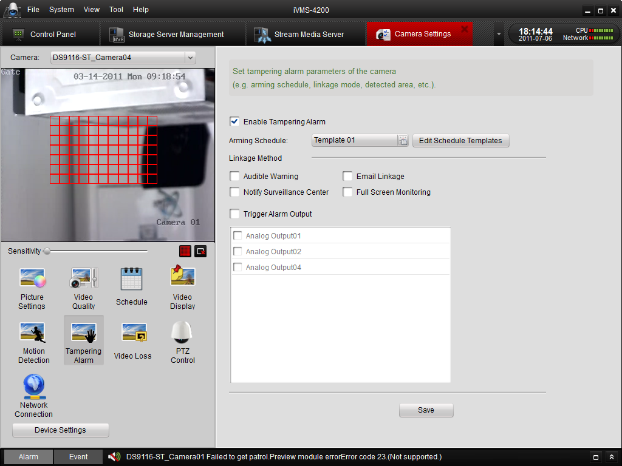
Figure 9.12 Tampering Alarm

- Configure time schedule for the tampering detection to take effect. The schedule template can also be edited in the Schedule configuration interface.
- Draw the video tampering area on the video image and set the sensitivity by moving the sliding bar. User can click the button to select the whole area for video tampering detection, or click the button to delete the selected tampering area.
Linkage Method Description
Audible Warning: trigger audio warning on the device when tampering detection is triggered.
Notify Surveillance Center: upload alarm information to the CMS software when tampering detection is triggered.
Trigger Alarm Output: activate 1 or multiple channels of alarm output when tampering detection is triggered. Users need to specify the corresponding alarm output channel (s) in the alarm output channel list.
Email Linkage: send an Email when tampering detection is triggered. The email account settings are configured under the Device ManagementConfigNetworkEmail Settings.
Full Screen Monitoring: switch to full screen to monitor the motion detection video.
After all the tampering settings are done, click to save the changes.

9.1.7 Video Loss
To configure the video loss detection function of the camera, please check Enable Video Loss checkbox in the Video Loss configuration interface (Figure 9.13), and select a time schedule for the video loss detection to take effect. The schedule template can be edited in the Schedule configuration interface.
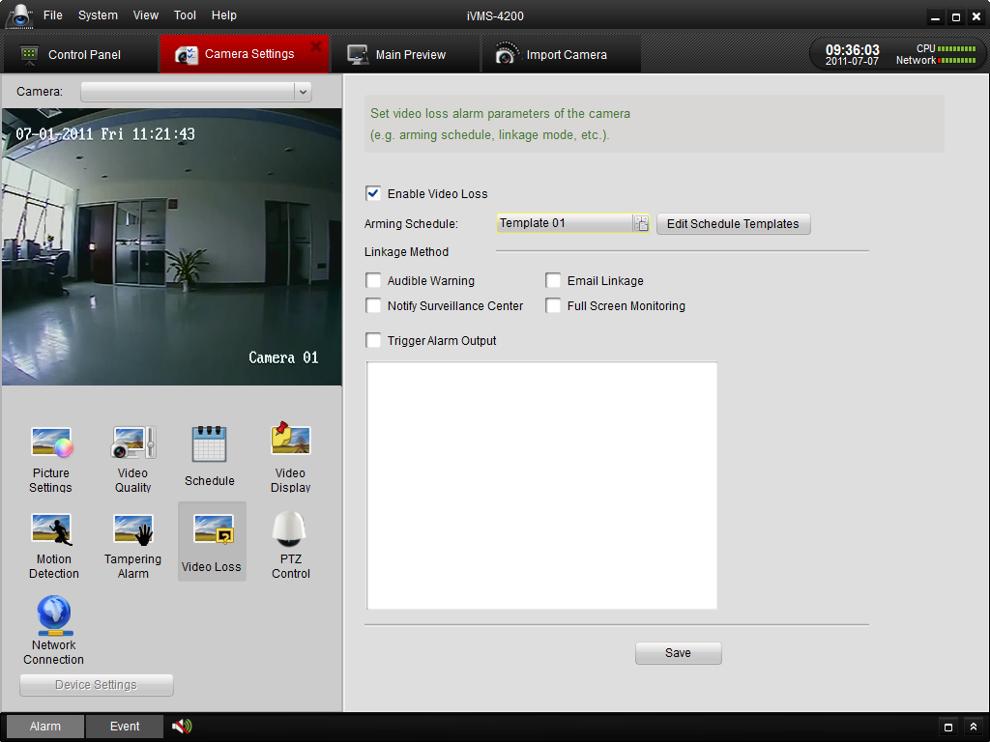
Figure 9.13 Video Loss Detection

Linkage Method Description:
Audible Warning: trigger audible warning on the device when video loss is detected
Notify Surveillance Center: upload alarm information to the CMS software when video loss is detected.
Trigger Alarm Output: activate 1 or multiple channels of alarm output when video loss detection is triggered. Users need to specify the corresponding alarm output channel (s) in the alarm output channel list.
Email Linkage: send an Email when video loss detection is triggered. The email account settings are configured under the Device ManagementConfigNetworkEmail Settings.
Full Screen Monitoring: switch to full screen to monitor on the video loss camera.
After all the video loss detection settings are done, click to save the changes.

9.1.8 PTZ Control
In the PTZ Control configuration page, you can specific the PTZ connection parameters, such as baud rate, data bits, stop bits, parity, flow control, PTZ protocol and PTZ address (Figure 9.14).
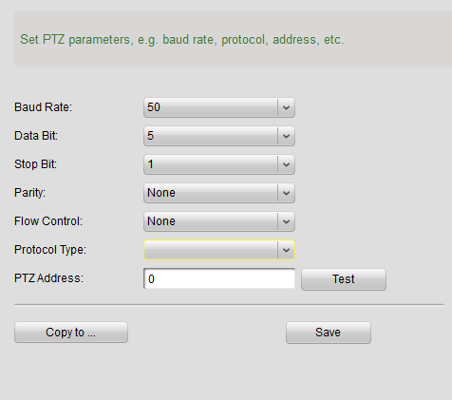
Figure 9.14 PTZ
Please note that all these PTZ parameters should be consistent with the local settings on the PTZ to ensure valid PTZ control.
Click to copy all the PTZ settings to another camera. After all the PTZ settings are done, click to save the changes.

9.1.9 Network Connection
In the Network Connection configuration page, you can specify the protocol, choose the stream type of the camera, and configure stream media server (Figure 9.15).
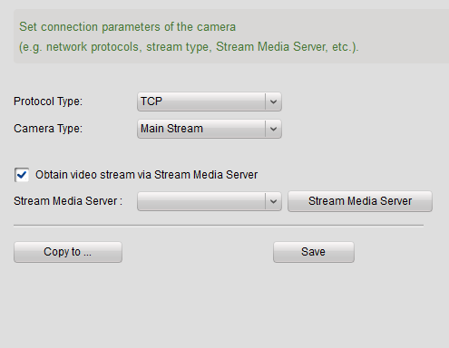
Figure 9.15 Network Connection

If Obtain Video Stream via Stream Media Server is enabled, please click, click Add in the popup dialog box and input the stream media server information to assign a stream media server for the stream.
Click to copy all the Connection settings to another stream. After all the Connection settings are done, click to save the changes.

9.2 Device Configuration
Click on the “Device Management” icon 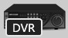 in the control panel.
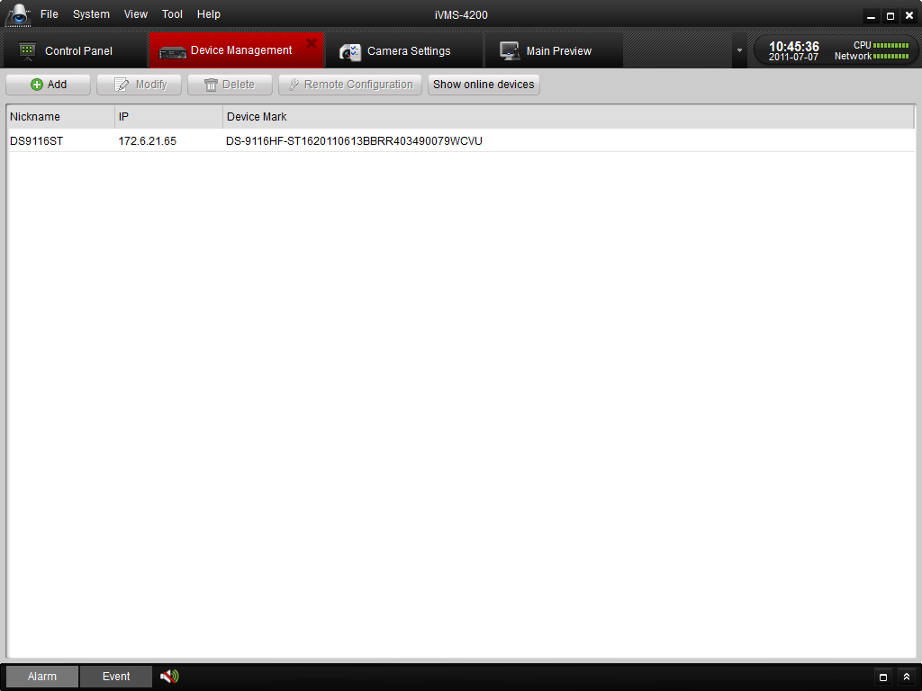
Figure 9.16 Device Configuration

Select the device you want to configure, and click button to enter the device configuration interface (Figure 9.16).
You can also enter the device configuration interface by clicking button in the Camera Import interface.
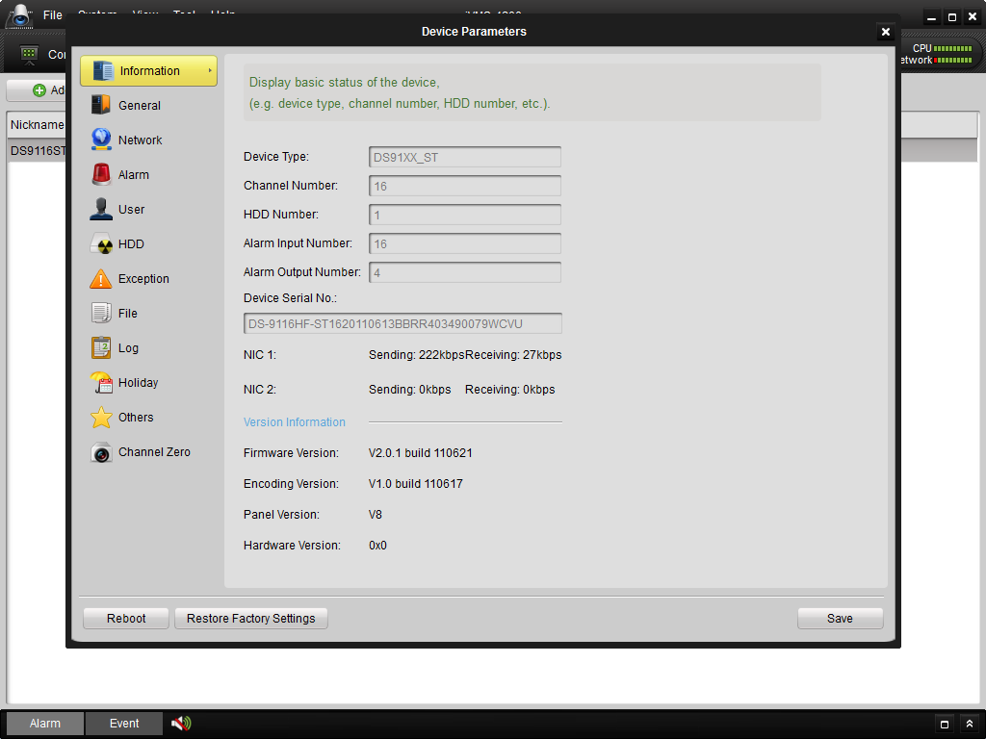
Figure 9.17 Device Configuration- General

9.2.1 Information
In this status page (Figure 9.16), you can check the basic information of the device, including device type, total channel number, HDD number, physical Alarm I/O number, Device Serial Number, version information and so on.
Figure 9.18 Device Configuration- Information

9.2.2 General
In the general configuration page (Figure 9.17), you can configure some general properties of the device.
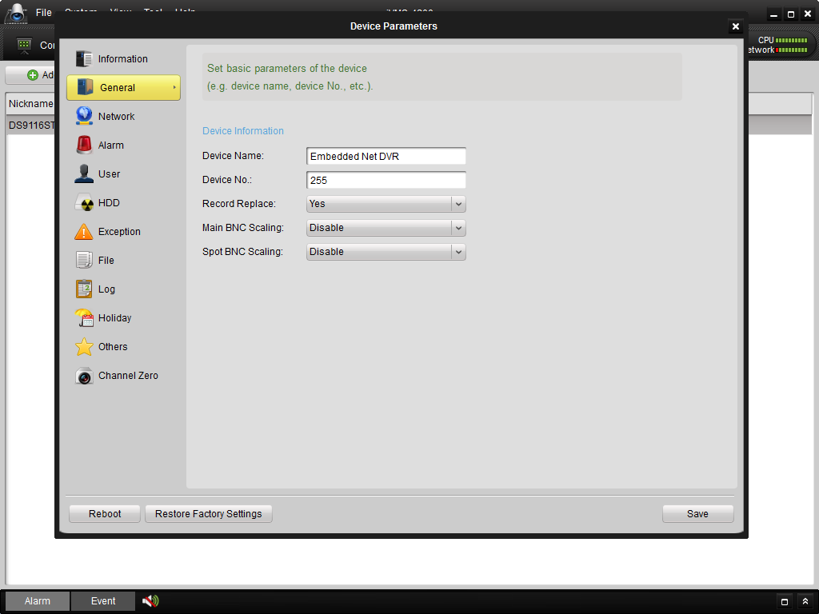
Figure 9.19 Device Configuration-General

Device Name: you can define the name of the device, which will be displayed on the device list of the software.
Device No.: device number for the remote controller.
Record Replace: overwrite HDDs when HDDs are full.
Main BNC Scaling: scale image display on the main BNC output.
Spot BNC Scaling: scale image display on the spot BNC output.

9.2.3 Network
In the network configuration page (Figure 9.19), you can configure network parameters for the device.
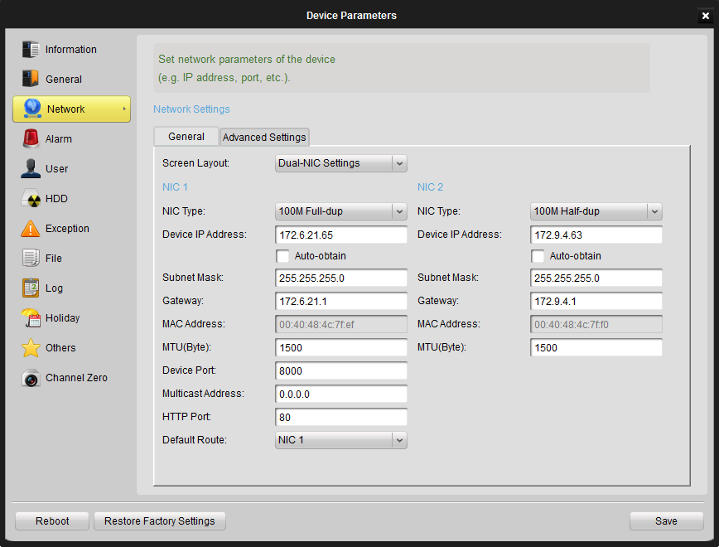
Figure 9.20 Device Configuration- Network

General Settings:
NIC Type: NIC type of the device.
Device IP Address: IP address of the device.
Device Port: network port of the device, the default port number is 8000.
Subnet Mask: sub net mask IP for the device.
Gateway: default gateway IP for the device.
MAC Address: Mac address of the device, this is a read-only field.
Multicast Address: multicast address of the device, please leave this field empty if multicast is not required.
MTU: the maximum transport unit, the default value is 1500.
Device Port: the port number of the device, the default value is 8000.
HTTP Port: Web servicer port, the default port number is 80.
Advanced Settings:
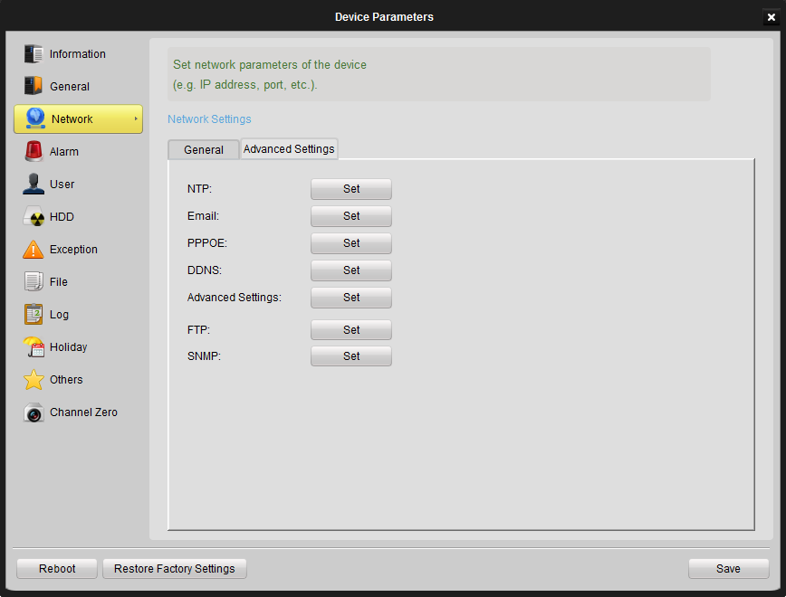
Figure 9.21 Device Configuration- Network Advanced Settings

NTP: NTP time synchronization. Click the Set button to configure NTP server and the time zone.
Email: Email account settings for the device. Click the Sett button to configure SMTP server parameters.
PPPOE: click the Set button to configure PPPOE parameters.
DDNS: click the Set button to configure DDNS parameters.
Advanced Settings: click the Set button to configure DNS Server Address, Alarm Host IP and Alarm Host Port.
FTP: click Set button to configure FTP-related parameters for picture upload.
SNMP: click Set button to configure SNMP parameters if necessary.

9.2.4 Alarm
In the alarm configuration page (Figure 9.20), you can configure Alarm I/O and linkage actions for the device.
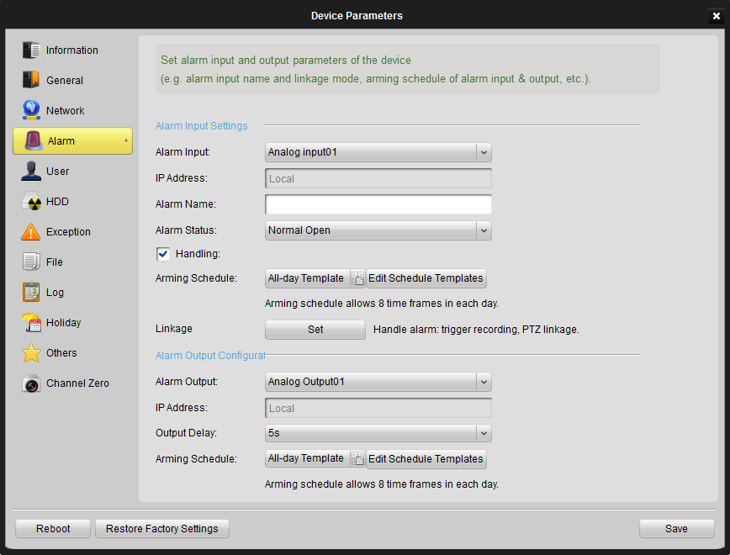
Figure 9.22 Device Configuration– Alarm

Alarm Settings:
Alarm Input: select an alarm input channel for configuration.
IP Address: IP address of the digital alarm input. “Local” stands for the hard-wired alarm input interface on the device. This is a read-only field.
Alarm Name: define a name for the alarm input channel.
Alarm Status: Normal Open stands for normally open status and Normal Closed stands for normally closed status.
You should check the Handling checkbox to activate alarm linked action settings.
Arming Schedule: set the time schedule to handle the alarm triggered actions. The schedule template is configured in “Schedule” settings page of camera Settings. Please refer to Section 9.1.3 for detailed description of operation steps.
Linkage: click Set to enter alarm linked action settings (Figure 9.21). Check the alarm action(s) which are required to be activated after the alarm input has been triggered, and select corresponding channel number if required.
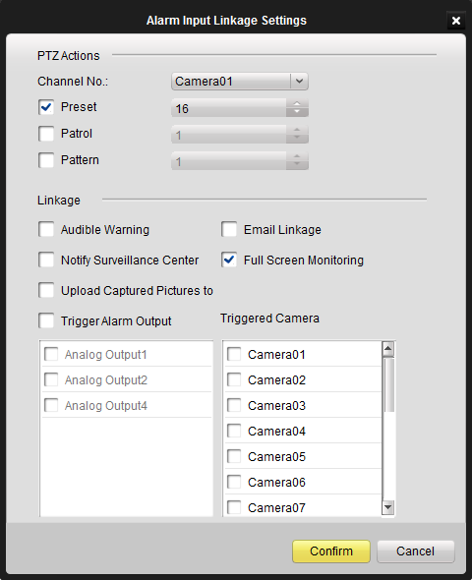

Figure 9.23 Alarm Handling Method

Alarm output settings:
Alarm Output: select an alarm output channel for configuration.
IP Address: IP address for the digital alarm output. “Local” stands for the hard-wired alarm output interface on the device. This is a read-only field.
Output Delay: select the delayed time duration for the alarm output.
Arming Schedule: set the time schedule to activate the alarm output. The schedule template is configured in “Schedule” settings page of camera configuration. Please refer to Section 9.1.3 for detailed information.

9.2.5 User
In the user configuration page (Figure 9.22), you can create users accounts and assign different permission for each account.
Click “Add”, “Modify” or ”Delete” to create/edit/delete a user account. The created user account(s) with basic information will be listed in the area below.
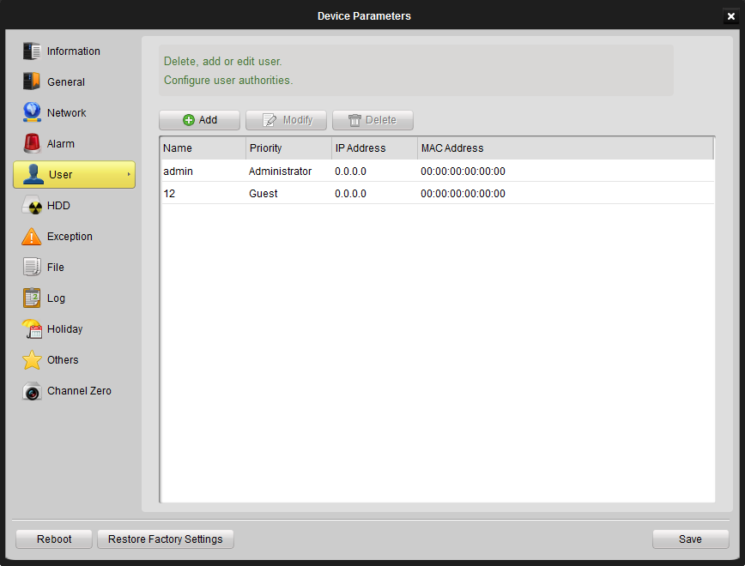
Figure 9.24 Device Configuration- User

To add a user, you can click Add, and then input the user’s basic information in the pop-out interface below.
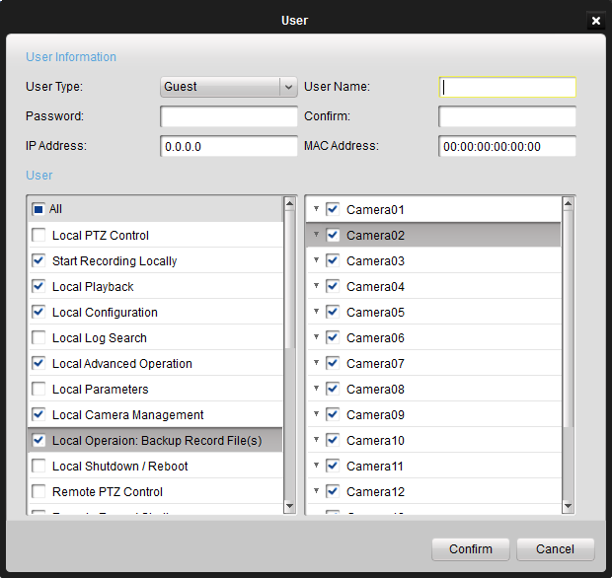
Figure 9.25 User Configuration

9.2.6 HDD
In the HDD configuration page (Figure 9.24), all the HDD installed on the device will be listed with basic information, and you can configure HDD groups by HDD Group Settings, or format the HDD by Format button on the HDD configuration interface.
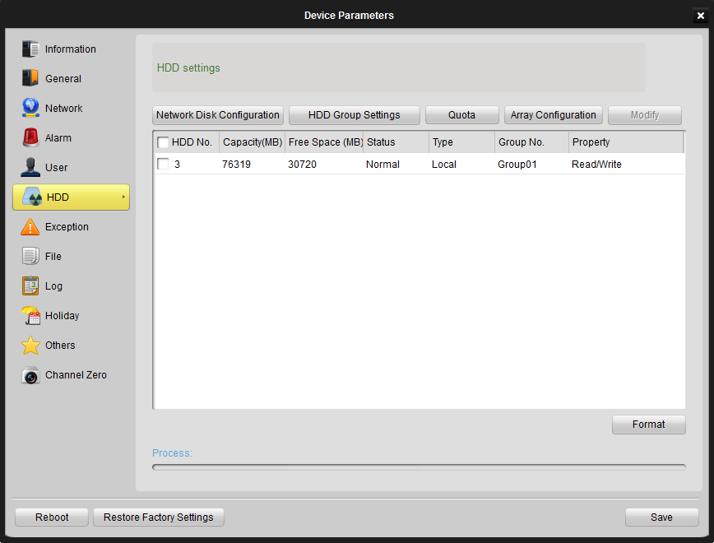
Figure 9.26 Device Configuration- HDD

9.2.7 Exception
You can select the exception type, and check the linkage actions accordingly under “Alarm Triggering Mode” (also select the channel number in “Alarm Output”). Different linkage actions can be configured for different exception type.

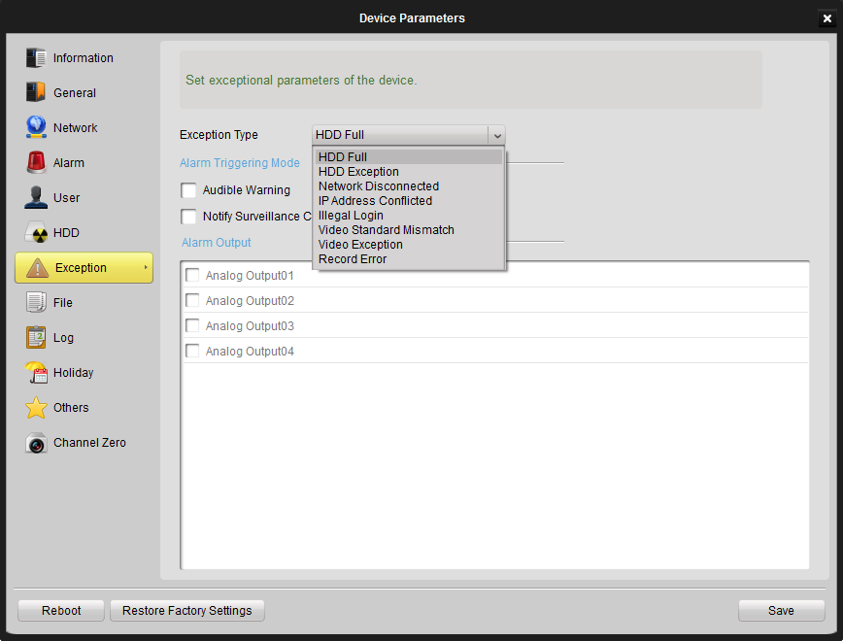
Figure 9.27 Device Configuration- Exception

9.2.8 File
Select the Channel Number, select different file property (i.e. All, locked, unlocked), define the start and end time of the record log files, and then click Search. The matched record files will be listed accordingly.
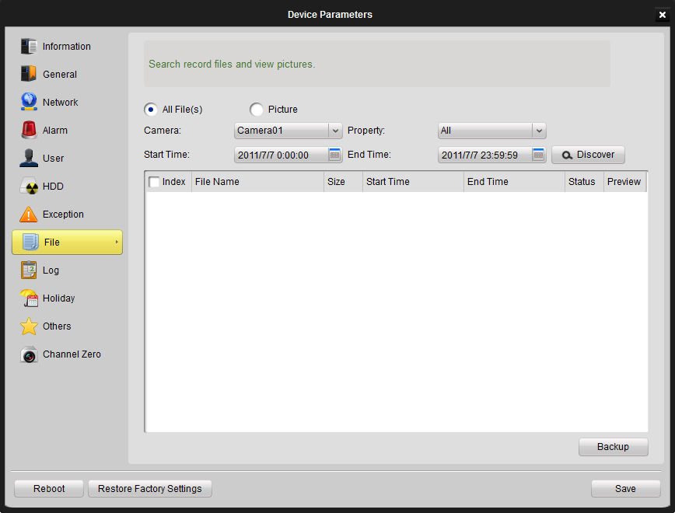
Figure 9.28 Device Configuration- File

If the device supports remote backup function, user can also select files and click Backup to back up all the selected record files.
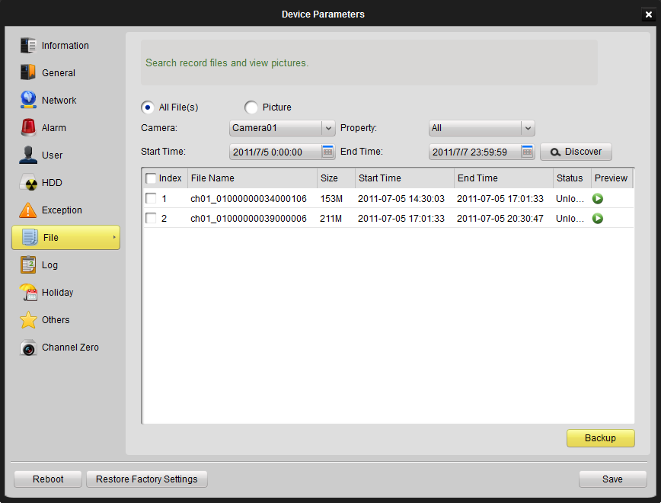
Figure 9.29 Device Configuration- File Backup

Similarly, captured pictures stored on local device can also be searched, played back and backed up. Picture types include Normal, Motion, Alarm, Continuous Capture, etc.

9.2.9 Log
Log file query on the local device (Figure 9.27). Select the Search Mode, select different Major Type and Minor Type of the log file, define the start and end time of the log files, and then click Search. The log will be listed accordingly.
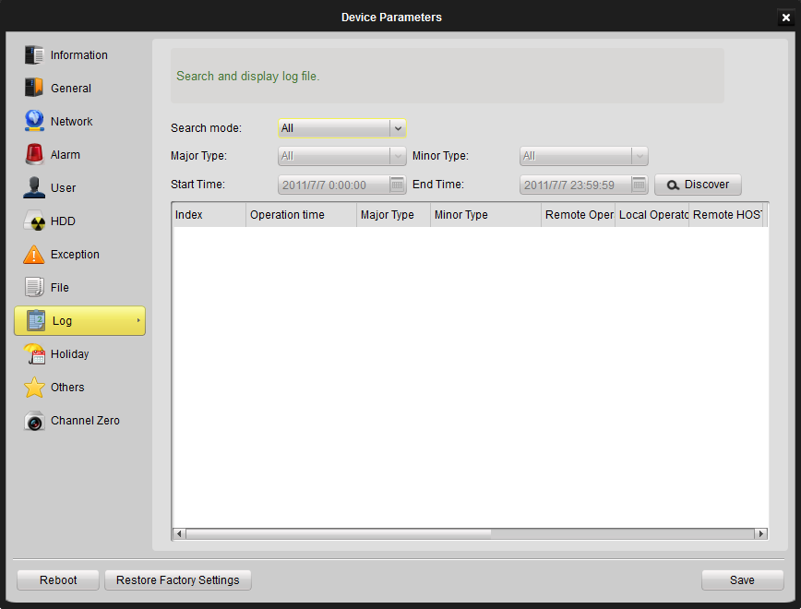
Figure 9.30 Device Configuration- Log

9.2.10 Holiday
In the holiday setting interface for the device, you can check the holiday settings and edit the holiday schedule.
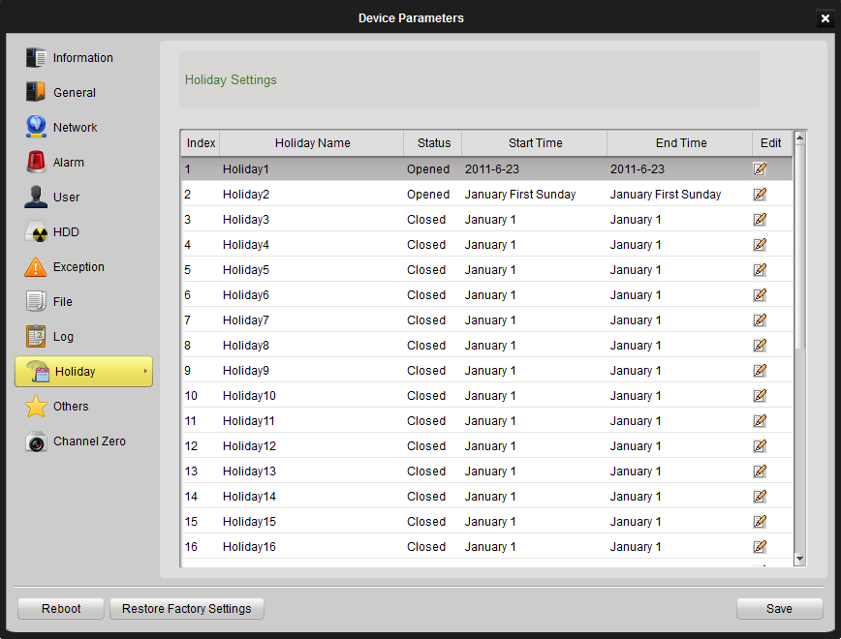
Figure 9.31 Device Configuration- Holiday

To edit the holiday schedule you click the edit icon on the right. Then you can set the start and end time for the holiday.
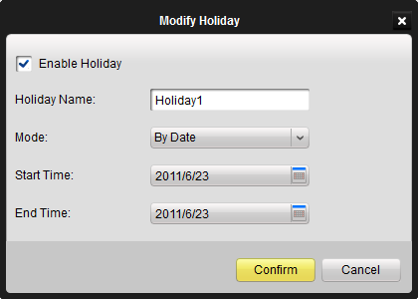
Figure 9.32 Device Configuration- Holiday Modification

9.2.11 Others
In this interface, you can set the RS232 information and remote upgrade information.
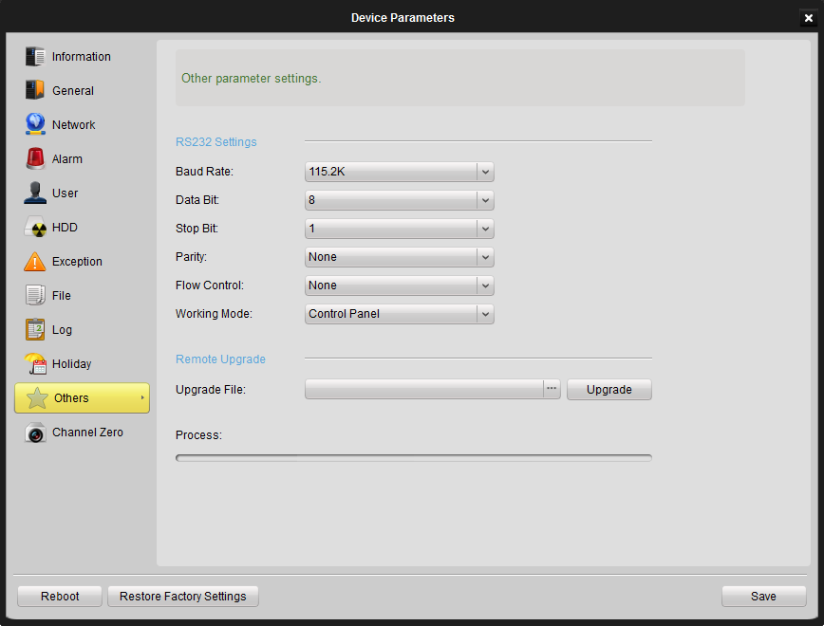
Figure 9.33 Device Configuration- Other

For the remote upgrading function, click […] to browse and select the upgrade file, and then click Upgrade to start upgrading. The upgrading process will be displayed and reboot is required when the upgrading process is finished.

9.2.12 Channel-Zero
Channel Zero is a feature to decrease the required bandwidth, when you remotely view many channels at the same time using web browser or remote client software.
Channel Zero is specially used for encoding the spot output port. You could set the spot output (zero-channel) encoding parameters, window divisions and the cycle mode. By this function, user could preview the video of the spot output, and it could save the bandwidth for user.
If the device supports Channel Zero feature and the channel number is set to be more than the analog channel number, the last channel of the device will be the Channel Zero. The priority of the Channel Zero is higher than IP camera channel. If you want to use the IP channel of the DVR, you need to set the channel number to be more than the summation of the analog and IP channel number, and zero-channel need this one channel to display.

You can enter the settings interface to configure the zero channel settings, e.g., enable/disable zero-channel coding, Max. bitrate, frame rate, screen layout, dwell time, and camera order.
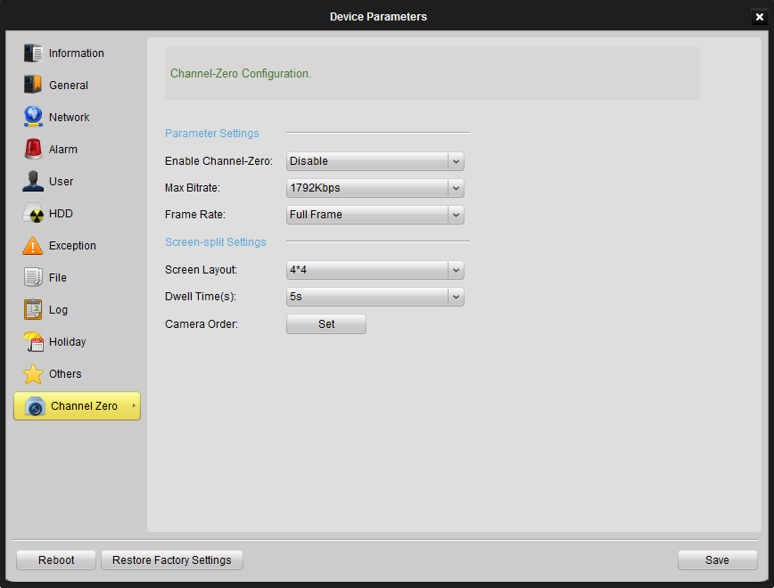
Figure 9.34 Device Configuration- Zero Channel

The camera order is to set the camera order for displaying.
Click Set to enter the Channel Sequence Settings interface. Select the screen split mode and then adjust the camera order as required. Refer to Figure 9.30.
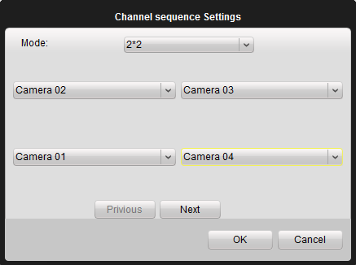
Figure 9.35 Zero Channel- Camera Order Settings

Chapter10. E-Map
Click View->E-map View on the menu bar or click 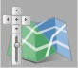 on the Control Panel to enter the main interface of E-map. Refer to the following figure:
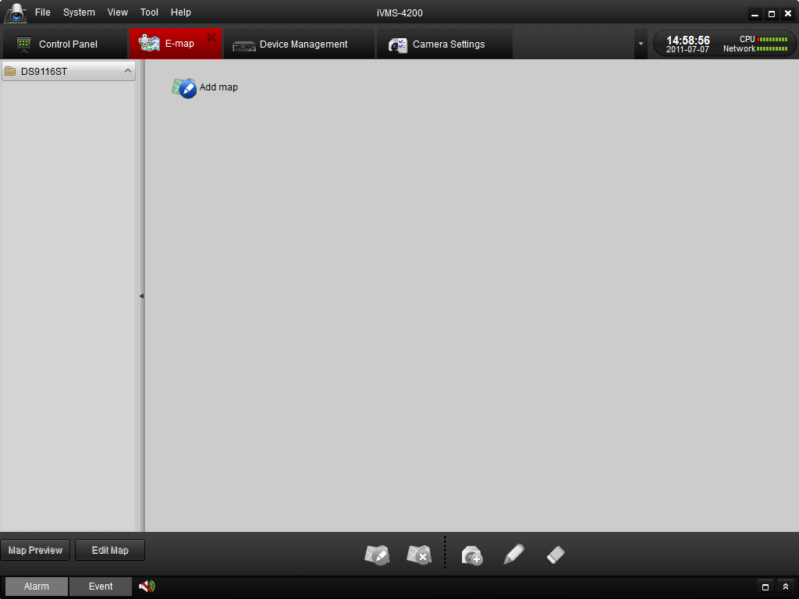

Figure 10.1 E-map

10.1 Adding a E-map
For the first time to use E-map, you are required to add a map first. Click Add Map icon to add a new map.
Note: Only one map can be added for each group.
Figure 10.2 Add E-map

Enter in name of Map, and select it from your local PC.
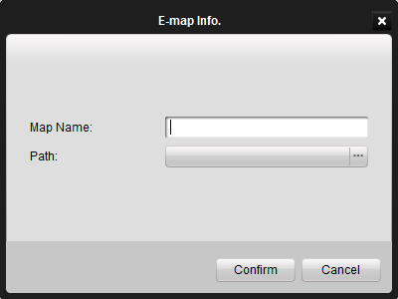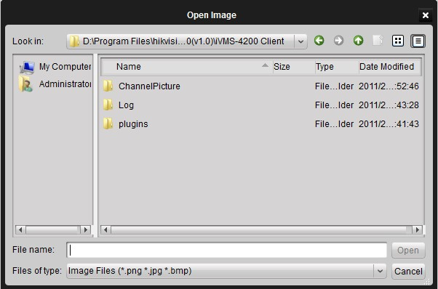
Figure 10.3 Enter E-map Information

Note: Map format should be *png, *jpg or *bmp.
After add map successfully, it shows on the window and name of map also appears on the list of group.
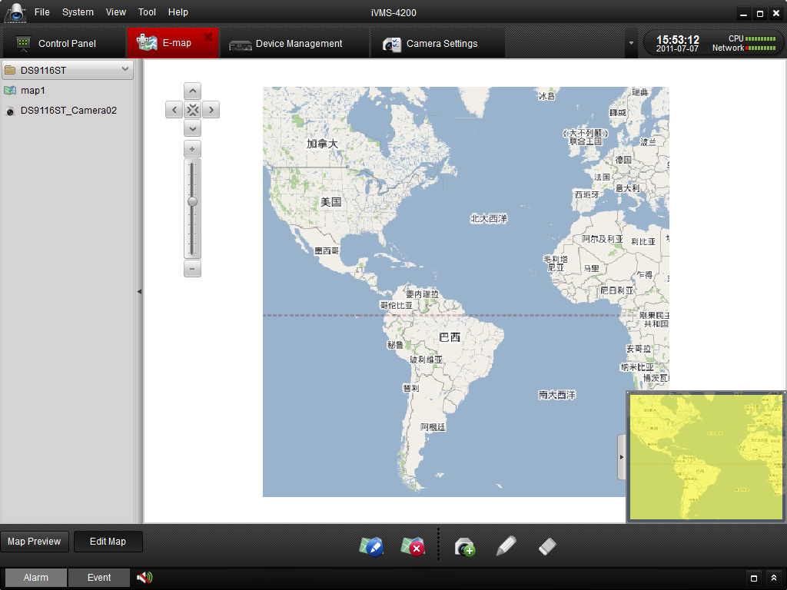
Figure 10.4 E-map Display

Toolbar buttons description:

Button | Description
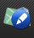 | Modify map, change map name or path.
 | Delete map.
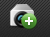 | Add hot spot on the map
 | Modify hot spot name and select which camera to show the map.
 | Remove selected hot spot from the map.
 | E-Map is under view state, the toolbar is not displayed.
 | E-Map is under edit state, the toolbar with the above icons is displayed.
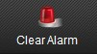 | Clear alarm display on E-Map manually. This icon only shows in Map Preview mode.

10.2 Editing a E-map
Click to show the editing toolbar, click or double click the map name on the left bar of the interface to show the map editing window. You can modify map name and change another map here.
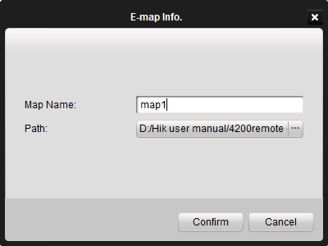
Figure 10.5 Edit E-map Information

To show the location of the camera on the map:
- Click and select which camera you want to add on the map as a hot spot, and then drag it to the right position.
- You can also just drag camera from the list on the left bar to the right position.
If there is alarm triggered, icon will appear near the camera icon.

Chapter11. Decoding Device Management
iVMS-4200 client software allows the access of the DS-6000DI, DS-6300DI and DS-6401HDI Series Decoder for decoding and outputting the network video signal from DVR, DVS, network Camera, network speed dome and encoder card as well as display of the video on TV wall.

11.1 Adding Decoding Device
Before controlling the decoder, user needs to add the decoder.
There are two ways to add a decoder.
- Click 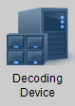to enter decoding device setting interface. And the click Add to add the decoding device.

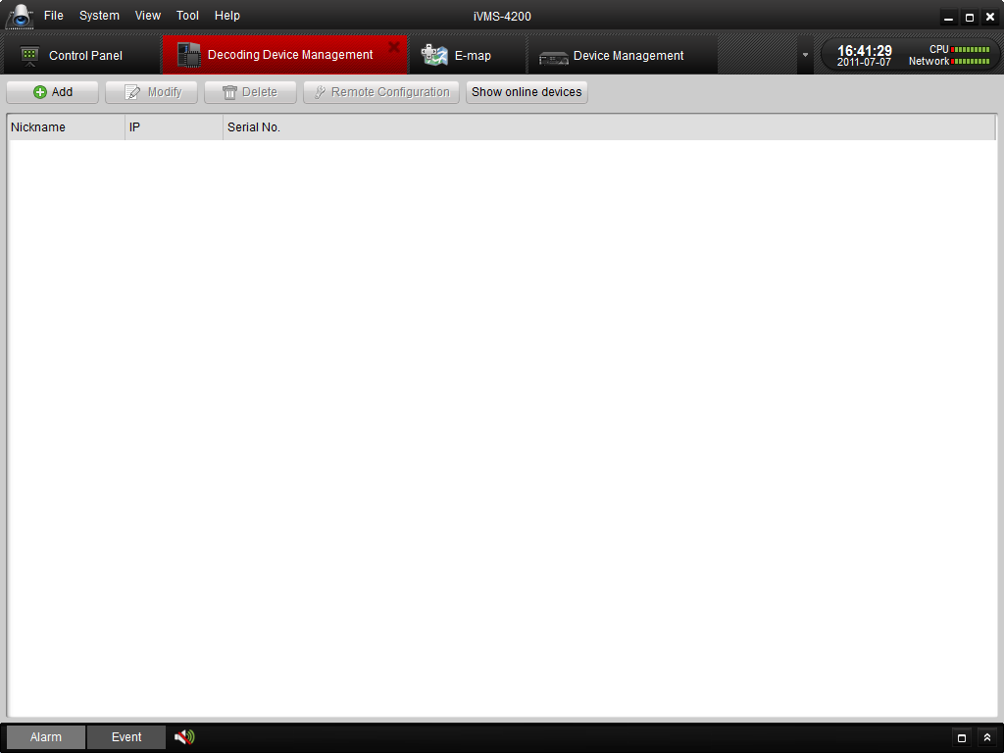
Figure 11.1 Decoding Device Management Interface
Input the information for the decoding device.
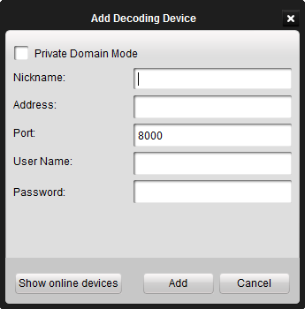
Figure 11.2 Add Decoding Device

11.2 Editing TV Wall
After adding the decoding device, the device name will be displayed in the device list on the left.

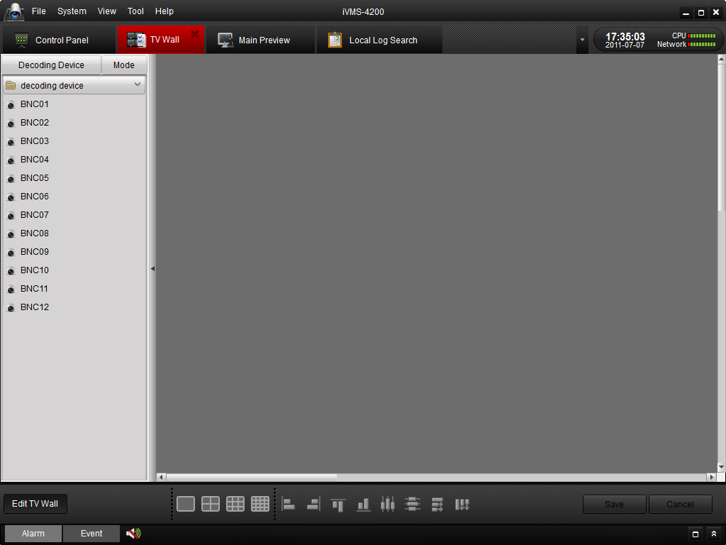
Figure 11.3 Edit TV Wall

Click to select output mode.
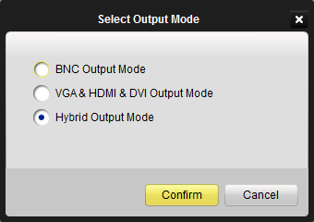
Figure 11.4 Select Video Wall Model

Click and drag one or more output (VGA or BNC) from the output list (Area 1) to the blank area (Area 2).
The channels of the decoder will be listed (Area 1).
Note: If the decoder supports VGA, it will display the VGA output. The DS-6300DI decoder supports simultaneous BNC and VGA outputs, and DS-6401HDI provides BNC, VGA, HDMI and DVI output.
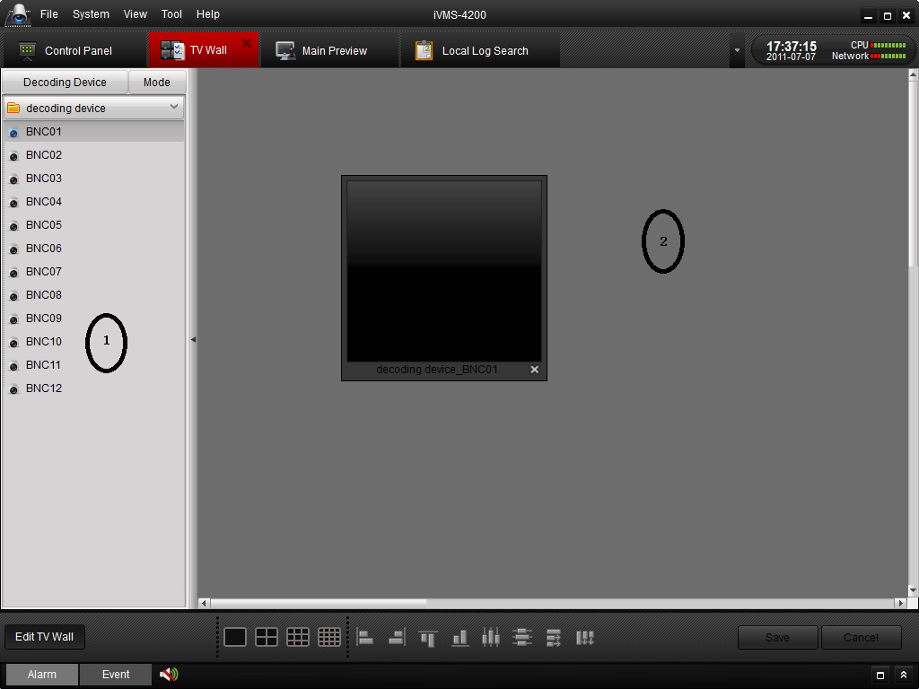

Figure 11.5 TV Wall Configuration

You can select 1/4/9/16 window-splitting layout by clicking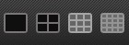.

Bottom Toolbar Description:
Button | Description | Button | Description
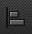 | Align Left |  | Align Right
 | Align Top |  | Align Bottom
 | Center and Vertical |  | Center and Horizontal
 | Distribute Horizontal Space |  | Distribute Vertical Space

Note: The decoding resource of DS-6000DI, DS-6300DI, DS-6101DI and DS-6401HDI is shown as below:
Resolution/Decoder Model | Decoding Channel Number
 | DS-6000DI |  |  | DS-6300DI |  |  | DS-6101  DI | DS-6400HDI
 | 6001DI | 6004  DI | 6008DI | 6301DI | 6304  DI | 6308DI | 6101  DI | 6401  HDI
CIF | 1 | 4 | 8 | 4 | 8 | 16 | 4 | 4
4CIF | 1 | 4 | 8 | 2 | 4 | 8 | 1 | 4
720P | N/A |  |  | 1 | 2 | 4 | N/A | 2
1080P | N/A |  |  | N/A |  |  | N/A | 1

11.3 Adding Cameras to TV Wall
Click the camera number on the left bar, and then add it to the TV Wall. There are three modes to add cameras into TV wall: Preview, Alarm and Cycle decoding.
Click 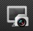 or 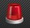 to switch between Preview and Alarm mode.
If it is in Preview mode, drag channel from left list to window, then it start decoding and show on the video wall.
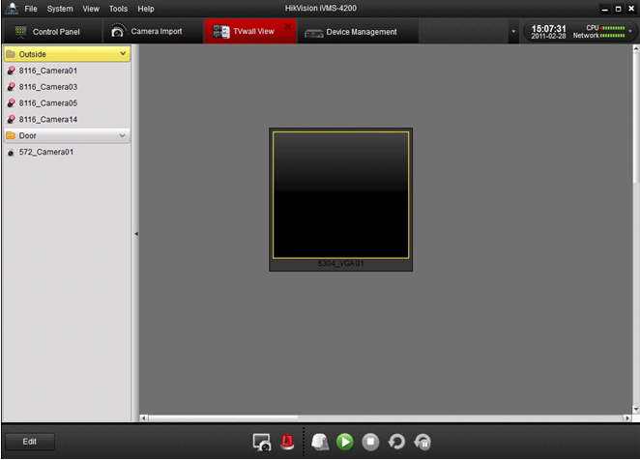
Figure 11.6 TV Wall Configuration

If it is in Alarm mode, clickin “Alarm Events” to start decoding channel when alarm occurred.
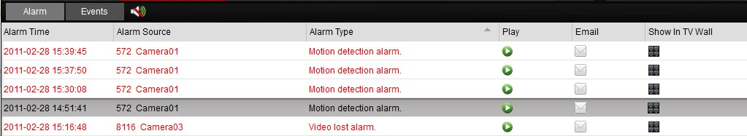
Drag the whole group into window and it start cycle decoding.
Pause / Recover cycle decoding
Right click window to pop up a dialog box and select Pause or Recover cycle decoding. User may also directly click / on the bottom.
Buttons | Description
 | Preview mode
 | Alarm mode
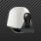 | PTZ mode
 | Start decoding
 | Stop decoding
 | Start cycle decoding
 | Stop cycle decoding

Click to save settings or to cancel the saving of settings of current edit mode interface.

11.4 PC Decoder
PC decoder is a computer which is installed with decoder card. Firstly install the card drivers before using it.
Run “Decoder Server” to enter the following interface:
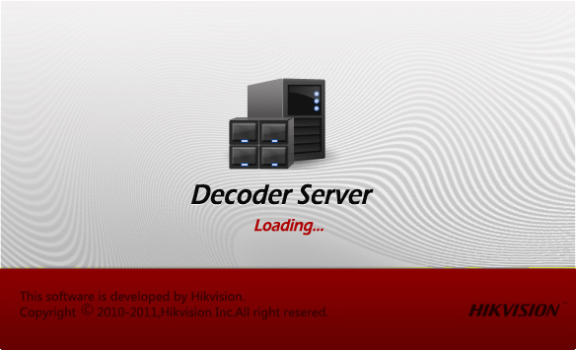
Figure 11.7 Run Decoder Server
After having installation, the computer can be used as a PC decoder. For instructions of using PC decoder, please refer to Chapter 11.1, 11.2 and 11.3.

Chapter12. Log

12.1 Log Query
Click 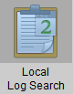 on the Control Panel to enter the Local Log Search interface. User is allowed to search logs by log type, minor log type, user, group, camera and start/end time. Select search criteria of log, and click Search to start searching. The matched logs will be listed on the display pane. Refer to Figure 12.1.
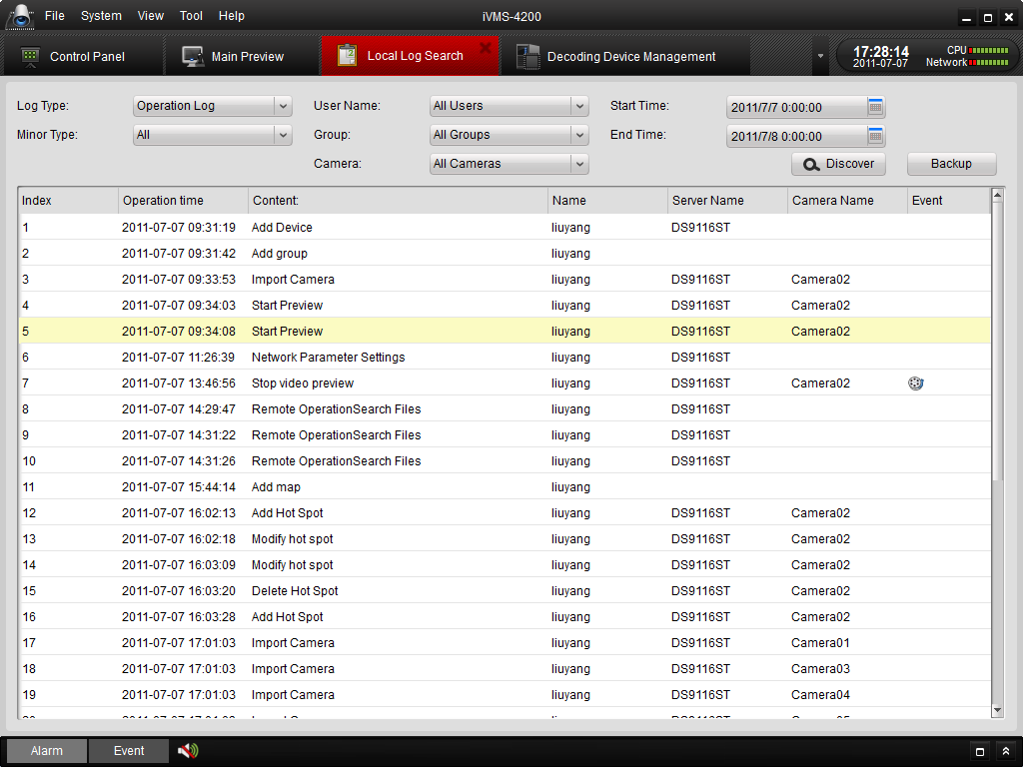
Figure 12.1 Log Search

12.2 Log Backup
Select the logs from the list and then click , the Backup Log dialog box pops out. Select saving path of log files and then click Backup icon. The log will be exported as .XML file.
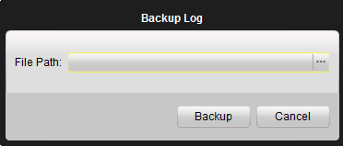
Figure 12.2 Log Backup to Device

12.3 Opening Log File
For the log files that have been backed up to local PC, you can open them by clicking FileOpen Log File from the menu bar to enter the Log File interface.

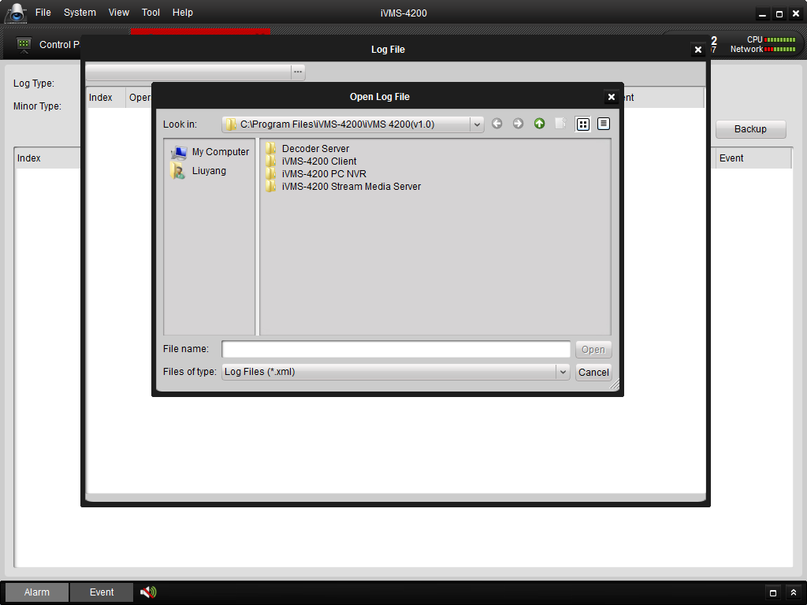
Figure 12.3 Open Log File
Click the button to browse the folders where the log files are located.
After selecting the log file, click to open the log file. Refer to Figure 12.4.

Chapter13. System Configuration
Click on the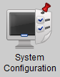 icon on the control panel to enter the system configuration interface.

13.1 General
In the General system configuration page (Figure 13.1), you can set general configuration for the local system.
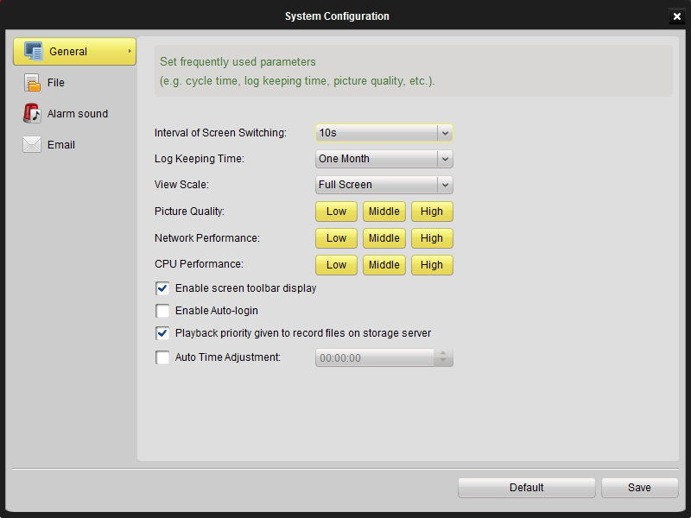
Figure 13.1 System Configuration-General

Interval of Screen Switching: switching the TV wall display. Unit: second.
Log Keeping Time: the expire time for the logs to be kept.
Picture Quality: general image quality settings. It can be set as low, middle and high according on your demands.
Network Performance: can be set as low, middle, and high.
CPU Performance: can be set as low, middle, and high.
Enable Screen toolbar display: Show toolbar at the bottom of window in preview, playback, etc. Refer to Figure 13.2.
Enable auto-logon: automatically login the software without user account validation.
NVR Playback Priority: Enable NVR playback priority during playback operation if required.
Users can click to save the new settings, or click to restore the default settings.
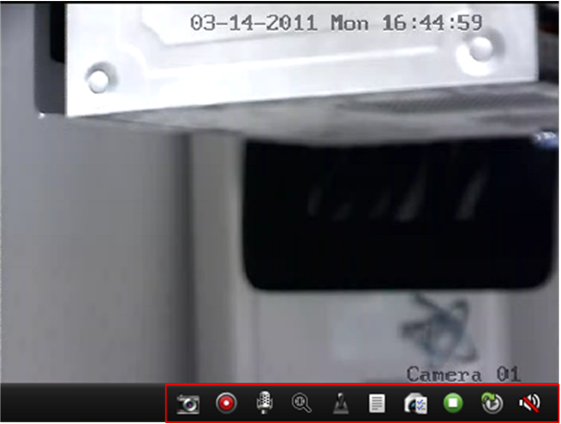
Figure 13.2 Enable Toolbar

13.2 File
In the File configuration interface (Figure 13.3), you can set the storage path to store video files, picture files and configuration file.
Click the button to browse the file and select the file directory accordingly.
You can click to save the new settings, or click to restore default setting.
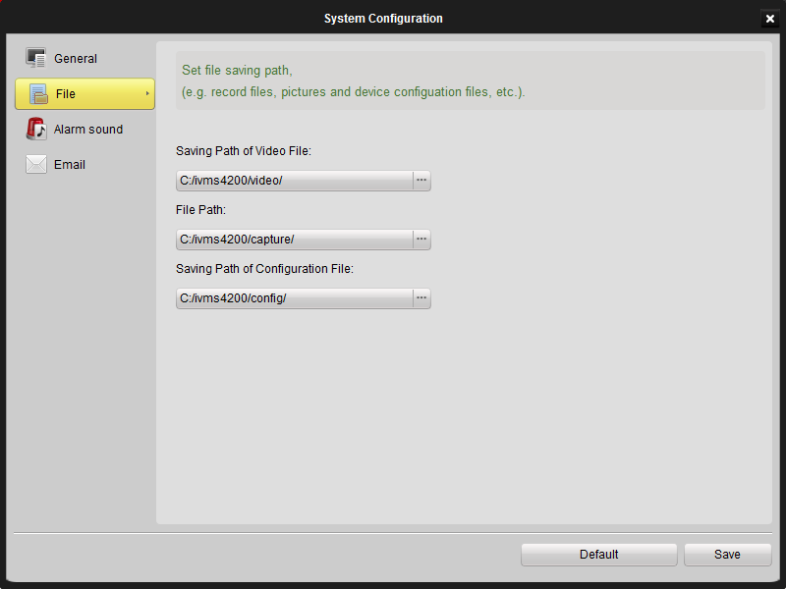
Figure 13.3 System Configuration- File

13.3 Alarm Sound
In the Alarm Sound configuration interface (Figure 13.4), you can select different audio wave file for different types of alarm.
Click button to open the file browser, and select an audio wav file for the selected alarm type.
You may also click the button to listen to the selected audio file.
You can click to save the current configuration, or click to restore the default settings.
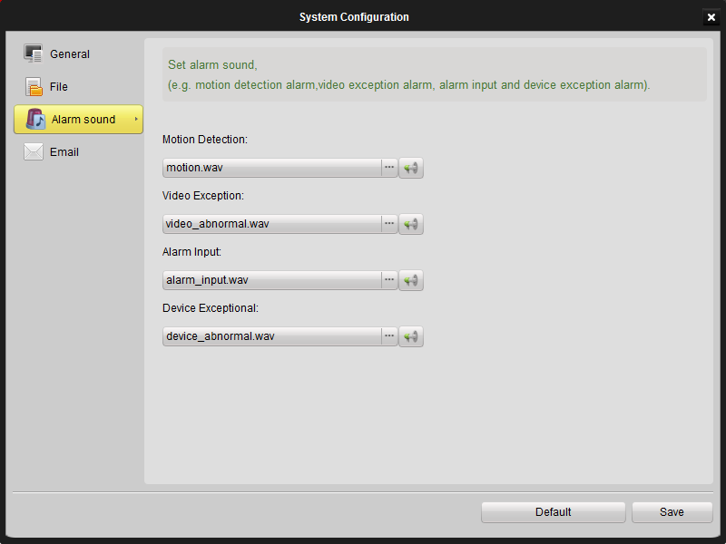
Figure 13.4 System Configuration-Alarm Sound

13.4 Email
In the email configuration interface (Figure 13.5), you can set the SMTP account information for the alarm action of the local software. Input correct SMTP information about the mail server and click to check if the test message can be send to the email address successfully.
You can click to save the new settings, or click to restore default settings
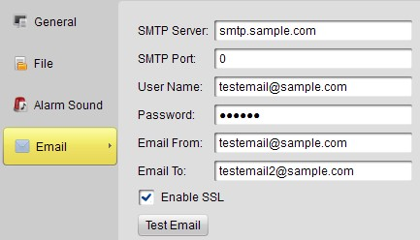

Figure 13.5 System Configuration- E-mail

Chapter14. FAQ

Live View
Question:
How to get the live view for the channels in the remote client from a HIKVISION device?
Answer:
Step 1: Add the device into the software device list; please refer to 4.1 Adding Device for more details.
Step 2: Add a channel from the device from the device list into a group. Please refer to 4.3 Adding a Camera Group for detailed information.
Step 3: Open the Main View interface from the Control Panel, and drag the camera from the group list on the left side to the display window, see 5.2 Starting Live View.

Recording
Question: How to set motion detection recording from a HIKVISION device?
Answer:
Step 1: Configure event recording mode in recording schedule setup. For motion detection recording on NVR, please refer to Section 6.2.3; and for motion detection recording on the device, please refer to Section 9.1.3.
Step 2: Configure Motion Detection parameters, including motion detection area, sensitivity and linkage options (please enable “Upload to Center” option for motion recording on NVR) in the camera configuration. Please refer to Section 9.1.5 for setup details of motion detection.

Playback
Question: How to search for video files recorded of certain event mode?
Answer:
Step 1: Go to Event Search panel and select an event type: motion or input (i.e. alarm input).
Step 2: Choose a camera in the group and specify a start time, then click Search button.
Step 3: Select a window, and double-click a video file from the search results list to play.

Configuration
Question: How to set encoding parameters in the device configuration?
Answer:
The encoding parameters should be set separately for each camera, and it is configured in “Camera Configuration” setup page. Click on the “Camera Configuration” icon in the control panel to enter the Camera Configuration interface.

